Name

Mathematics Stage 4
Rates

Book 1 | Simplify and convert rates  Solve problems involving rates  Distance-time graphs | Version: 260827  Feedback:  https://MrDingMaths.com
Contents
Syllabus Content 2
Learning Intention 3

Syllabus Content
MA4-RAT-C-01 solves problems involving ratios and rates, and analyses distance–time graphs
Recognise and simplify rates
- Explain the differences between ratios and rates
- Represent given information as a simplified rate
- Convert between units for rates
Solve problems involving rates
- Solve a variety of real-life problems involving rates
- Examine financial applications of rates, such as best buys
Interpret and construct distance–time graphs from authentic data
- Interpret distance–time graphs made up of straight-line segments with a negative, zero or positive slope
- Calculate speeds for straight-line segments of given distance–time graphs
- Create distance–time graphs made up of straight-line segments

Introduction to Rates

- Review
- Recall simple rate problems
- A car travels 30 km in 1 hour.  How far would it travel in 5 hours? | - A student earns $300 in a day where she works 10 hours. How much does she earn per hour?
- Write $28 for 4 kg as a fraction with units. | - Simplify $\frac{18}{6}$

- Rates and Ratios
Ratio: Compares quantities with the same units (e.g., student : teacher).
Rate: Compares quantities with different units (e.g., distance / time).

Rates show a division of one quantity by another.
Always include units in rates.
The slash (/) means "per" or "for each".
Example: 40 km/h = "40 km per hour" or 40 km for each hour.

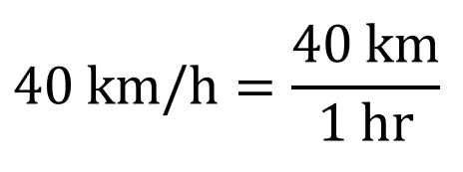
Write rates as fractions for clarity.
These fractions show division, not parts of a whole.
Always write the units.

- Key Ideas
- Ratios and rates are both ways of ………………………… quantities.
- Ratios compare two similar quantities, while rates compare two quantities with ……………… units.
- Rates need to specify the …………………
- A rate can be written as a …………………; this represents division, not parts of a whole.
- 8 students : 12 students is a ………………, $8 for 12 kg is a …………………

- Simplifying Rates
Simplifying a rate means to write it as a unit rate; the second quantity is 1.
- Write the rate as a fraction with units.
- Divide both quantities by the denominator.
You can do this by entering the fraction in a calculator
- Rewrite the simplified rate using the slash (/).

- Example Simplify rates
150 heartbeats every 3 minutes.  1. $\frac{150 beats}{3 minutes}$2. $\frac{150 beats}{3 minutes}\frac{÷3}{÷3}=\frac{50 beats}{1 minute}$  3. $=50 beats/minute$ | $28 for 4 kilograms  1. $\frac{\$28 }{4 kg}$  2. $\frac{\$28 }{4 kg}\frac{÷4}{÷4}=\frac{\$7}{1 kg}$3. $=\$7/kg$

- Guided Practice
Simplify these rates
- $84 for every 4 people  $$\frac{\$84}{4 people} \frac{÷4}{÷4}=\frac{\$ }{1 person}$$  $=\$$ …… /person  $21/person | - 21 apples for $3  $$\frac{21 apples}{\$3} \frac{÷ }{÷ }=\frac{ apples}{\$1}$$  $=$ …… apples /$1  7 apples/$1
- 300 words in 5 minutes  60 words/min | - $10 per 2.5 kg  $4/kg
- $18 for 5 kg of seed  $3.60/kg | - 3 kg of seed per 2 m²  1.5 kg/m²

- Key Ideas
- Simplifying a rate involves finding the …………… rate.
- A rate is called a unit rate if the second quantity is ………
- This can be done on a calculator by entering the rate as a ……………………

Foundation
- Simplify these to unit rates.
- $12 in 4 hours  $$\frac{\$12}{4 hours}=\frac{\$ }{1 hour}$$  = $……… /hour  $3 / h | - 15 goals per 3 games  5 goals / game | - $160 for 6 hours  $26.67 / h
- $17.50 for every 5 kg  $3.50 / kg | - 36000 cans in 8 hours  4500 cans/ h | - 80 mm rain in 5 days  16 mm / day
- 15 km in 60 minutes  0.25 km / min | - 78 runs for 12 overs  6.5 runs / over | - 91 people in 3 buses  $30.\dot{3}$ people / bus
- 448 km in 8 hours  56 km / h | - $16.50 for 6 kg  $2.75 / kg | - 243 km using 30 litres  8.1 km / L

- A lift should carry no more than 1600 kg or 20 people.
What is this weight allowance, in kg/person?

80 kg / person
- The cost of 53 litres of petrol is $73.67. Express this cost in $/L

$1.39 / L
- 30 salad rolls were bought to feed 20 people at a picnic. The total cost was $120.
Find these unit rates:
- Salad rolls/person  1.5 rolls / person | - Cost/person  $6 / person | - Cost/roll  $4 / roll

Development
- On a particular day, Dr Rosanna starts seeing patients at 8:30 am and finishes by 5:30 pm.
If she saw 40 patients that day, then what is the rate at which Dr Rosanna saw her patients, in patients/hour?

4.44 patients / hr
- Harvey finished a 10 km race in 37 min 30 sec.
Jack finished a 16 km race in 53 min 15 sec.
- Calculate the running rate of Harvey.  $0.2\dot{6}$ km / min | - Calculate the running rate of Jack.  0.3 km / min | - Who ran faster?  Jack

- A car uses 24 L of petrol to travel 216 km. Express these quantities as a simplified rate in:
- Kilometres per litre  9 km/L | - Litres per kilometre  $\frac{1}{9}$ L/km | - How can you convert from km/L to L/km?  Flip the fraction (take the reciprocal)

- Harvey gets paid $296 per day and works 8 hours per day.
Jackie gets paid $1500 per week and works 46 hours per week.
Who has the higher hourly rate, and by how much?

Harvey by $4.39 / hr

Mastery
- Tom was 120 cm tall when he turned 10 years old.
He was 185 cm tall when he turned 20 years old.
Find Tom’s average rate of growth per year between 10 and 20 years of age.

Growth = 185 - 120 = 65 cm
Time = 20 - 10 = 10 years
Average rate = 65÷10= 6.5 cm / year
- The temperature was 20$°$C at 9 am. At noon the temperature had risen to 32$°$C.
What was the average increase in temperature per hour?

Temperature increase = 32 - 20 = 12°C
Time = 12 - 9 = 3 hours
Average increase = 12/3 = 4°C / hour
- The Burwood Football Club had 12 000 members.
After five successful years, they now have 18 000 members.
What has been the average rate of membership growth per year for the past 5 years?

Membership increase = 18000 - 12000 = 6000 members
Time = 5 years
Average rate = 6000/5 = 1200 members / year
- A car had a full tank of 56 L at the start of a 75 km journey.
At the end of the journey, the fuel tank was three quarters full.
What is the fuel consumption rate, in kilometres per litre?

Fuel consumed = 56 - (3/4)(56) = 56 - 42 = 14 L
Fuel consumption rate = 75/14 = 75/14 ≈ 5.36 km / litre

Review of Converting Units

- Length Conversions
When converting to a larger unit, we divide, since we will need fewer units.
When converting to a smaller unit, we multiply, since we will need more units.
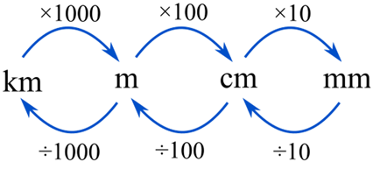

- When converting to a larger unit, we …………………, since we will need fewer units.
- When converting to a …………… unit, we multiply, since we will need more units.
- Convert these units of length. Only show the operation.
You do not need to find the answer.
- 3.6 km  = $3.6×1000$ m | - 8.4 mm  = ……………… cm  $$8.4÷10$$ | - 2.9 m  = ……………… cm  $$2.9×100$$
- 7000 m  = ……………… km  $$7000÷1000$$ | - 594 cm  = ……………… m  $$594÷100$$ | - 40 mm  = ……………… cm  $$40÷10$$
- 0.964 m  = ……………… mm  $$0.964×1000$$ | - 0.658 m  = ……………… cm  $$0.658×100$$ | - 620 mm  = ……………… m  $$620÷1000$$
- 14300 m  = ……………… km  $$14 300÷1000$$ | - 86 cm  = ……………… m  $$86÷100$$ | - 3.69 cm  = ……………… mm  $$3.69×10$$
- 70 mm  = ……………… m  $$70÷1000$$ | - 630 m  = ……………… km  $$630÷1000$$ | - 3600 cm  = ……………… m  $$3600÷100$$
- 4 km  = ……………… cm.  $$4×100 000$$ | - 0.78 km  = ……………… mm  $$0.78×1 000 000$$ | - 72945 mm  = ……………… m  $$72 945÷1000$$

- Metric Prefixes
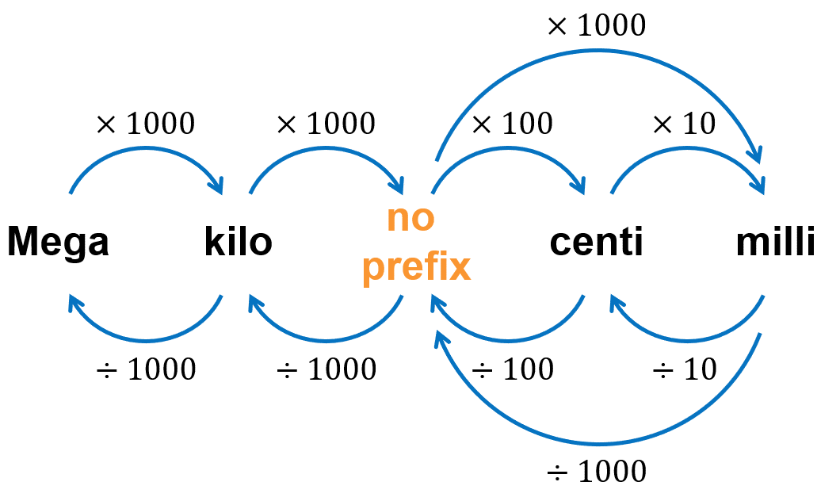

- Convert these units of capacity. The base unit is litres.
Only show the operation. You do not need to find the answer.
- 35 mL  = $35÷1000$ L | - 15.9 L  = ……………… mL  $$15.9×1000$$ | - 1.65 L  = ……………… mL  $$1.65×1000$$
- 15 000 mL  = ……………… L  $$15 000÷1000$$ | - 0.06 L  = ……………… mL  $$0.06×1000$$ | - 8000 L  = ……………… kL  $$8000÷1000$$
- 0.015 L  = ……………… mL  $$0.015×1000$$ | - 4725 L  = ……………… kL  $$4725÷1000$$ | - 95 mL  = ……………… L  $$95÷1000$$

- Convert these units of mass. The base unit is grams.
A tonne is 1 Megagram (1000 kg)
- 2.63 kg  = $3.63×1000$ g | - 7.1 g  = ……………… mg  $$7.1×1000$$ | - 17.84 kg  = ……………… g  $$17.84×1000$$
- 8000 kg  = ……………… t  $$8000÷1000$$ | - 4300 g  = ……………… kg  $$4300÷1000$$ | - 2740 mg  = ……………… g  $$2740÷1000$$
- 0.63 t  = ……………… kg  $$0.63×1000$$ | - 4.8 kg  = ……………… g  $$4.8×1000$$ | - 690 g  = ……………… kg  $$690÷1000$$
- 21.59 t  = ……………… kg  $$21.59×1000$$ | - 700 kg  = ……………… t  $$700÷1000$$ | - 80 g  = ……………… kg  $$80÷1000$$
- 7 mg  = ……………… g  $$7÷1000$$ | - 6.06 kg  = ……………… g  $$6.06×1000$$ | - 1.07 t  = ……………… kg  $$1.07×1000$$

- Units of Time
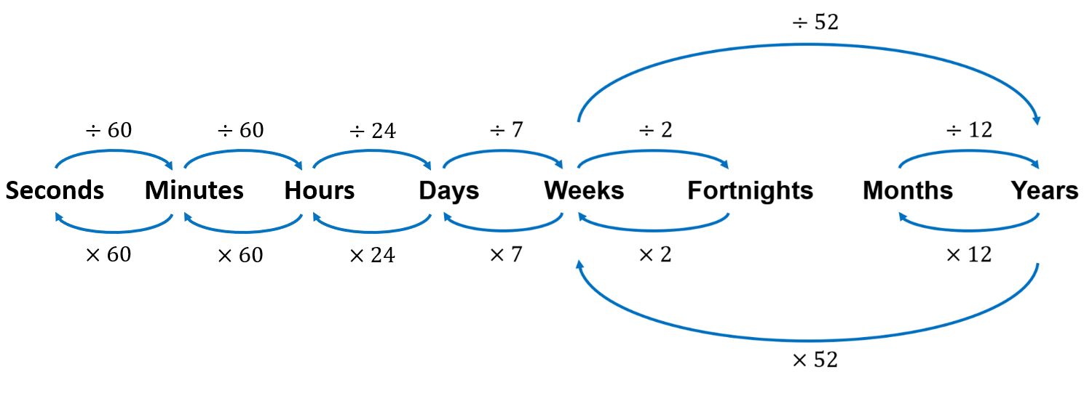

- Convert these units of time. Only show the operation. You do not need to find the answer.
- 15 min  = $15÷60$ h | - 200 min  = ………………… h  $$200÷60$$ | - 300 s  = ………………… min  $$300÷60$$
- 193 min  = ………………… s  $$193×60$$ | - 4.5 h  = ………………… min  $$4.5×60$$ | - 635 min  = ………………… h  $$635÷60$$
- 4 h 37 min  = ………………… min  $$4×60+37$$ | - 47 min 12 s  = ………………… s  $$47×60+12$$ | - 5 days 17 h  = ………………… h  $$5×24+17$$
- 100 h  = ………………… days  $$100÷24$$ | - 1 week  = ………………… h  $$7×24$$ | - 10 000 h  = ………………… days  $$10 000÷24$$

- Units of Area
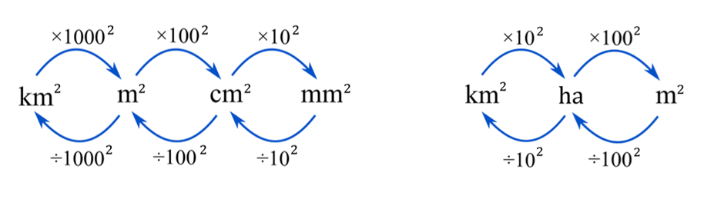

- Convert these units of area.
- 2.6 ha  = $2.6×{100}^{2}$ m² | - 4.9 m²  = ………………… cm²  $$4.9×{100}^{2}$$ | - 14 cm²  = ………………… mm²  $$14×{10}^{2}$$
- 63 000 m²  = ………………… ha  $$63 000÷{100}^{2}$$ | - 127 000 cm²  = ………………… m²  $$127 000÷{100}^{2}$$ | - 24.8 cm²  = ………………… mm²  $$24.8×{10}^{2}$$
- 5.671 km²  = ………………… cm²  $$5.671×100 {000}^{2}$$ | - 298 000 m²  = ………………… km²  $$298 000÷{1000}^{2}$$ | - 2.4 km²  = ……………… ha  $$2.4×{10}^{2}$$

Converting Rates

- Converting Rates
To convert rates:
- Write the rate as a fraction with units.
Numerator is the first quantity.
Denominator is 1.
- Convert the quantities to the required units.
- Simplify the fraction using a calculator.

- Example Convert rates (one quantity)
Convert 120 c/L to $/L  1. $\frac{120 c}{1 L}$ $=$ $\frac{\$\left( \right)}{1 L}$2. $=$ $\frac{\$\left(120÷100\right)}{1 L}$3. $=\$1.20/L$ | Convert $35/kg to $/g  1. $\frac{\$35}{1 kg}$ $=$ $\frac{\$35}{\left( \right)g}$2. $=$ $\frac{\$35}{\left(1×1000\right)g}$3. $=\$0.035/g$

- Guided Practice
Convert these rates.
- $15/kg to $/g  $$\frac{\$15}{1 kg}=\frac{\$15}{ g}$$  $=$  $0.015/g | - 13 L/h to mL/h  $$\frac{13L}{1 h}=\frac{ mL}{1 h}$$  $=$  13000 mL/h
- 900 km/h to km/min  15 km/min | - 34.5 m/s to m/h  124 200 m/h
- 0.6 c/min to c/h  36 c/h | - 0.47 g/mL to g/L  470 g/L

- Example Convert rates (both quantities)
Convert 72 L/h to mL/s  1. $\frac{72 L}{1 hr}$ $=$ $\frac{\left( \right) mL}{( ) s}$  2. $=$ $\frac{\left(72×1000\right) mL}{(1×60×60) s}$3. $=20 mL/s$ | Convert 35c/min to $/hr  1. $\frac{35c}{1 min}$ $=$ $\frac{\$\left( \right)}{( ) hr}$  2. $=$ $\frac{\$\left(35÷100\right)}{(1÷60) hr}$3. $=\$21/hr$

- Guided Practice
Convert these rates.
- 45 L/h to mL/s  $$\frac{45 L}{1 hr}=\frac{ mL}{ s}$$  $=$  12.5 mL/s | - $11/kg to cents/g  1.1 c/g
- 29 L/min to mL/s  $483.\dot{3}$ mL/s | - 125 kg/s to t/min  7.5 t/min
- 57 km/h to m/s  $15.8\dot{3}$ m/s | - 8.2 kg/day to g/min  5.69 g/min

- Key Ideas
- When converting rates, write the rate as a ……………………
- Convert the numerator and/or denominator to the required units by ………………… or ……………………
- Then use a ………………… to find the simplified rate.

Foundation
- Convert these units
- 6 L/h to mL/h  $$\frac{6 L}{1 h}=\frac{ mL}{1 h}$$  $=$ ………… mL/ h  6000 mL/h | - 6 L/h to kL/h  $$\frac{6 L}{1 h}=\frac{ kL}{1 h}$$  $=$ ………… kL/ h  0.006 kL/h | - $18/kg to c/kg  1800 c/kg
- 72 km/h to km/min  $$\frac{72 km}{1 h}=\frac{72 km}{ min}$$  $=$ ………… km/min  6000 mL/h | - 72 km/min to km/h  $$\frac{72 km}{1 min}=\frac{72 km}{ h}$$  $=$ ………… km/ h  4320 km/h | - 4.8 L/min to L/s  0.08 L/s
- 20 m/s to m/h  72 000 m/h | - 500 g/L to g/mL  0.5 g/mL | - 560 c/kg to $/kg  $5.60/kg
- 750 kg/m² to kg/ha  7 500 000 kg/ha | - 0.8 c/m to c/km  800 c/km | - 400 mL/h to mL/s  $0.\dot{1}$ mL/s
- 5 t/ha to kg/ha  5000 kg/ha | - $150/year to $/month  $12.5/mth | - 300 cm/year to cm/week  5.77 cm/wk

- The local council gets 2190 complaints per 3 years. How many is this per month?

$60.8\dot{3}$ complaints/mth
- The cost of 50 litres of petrol is $94.68. Express this cost in c/L to 2 d.p.

189.36 c/L
- Complete the following to convert these rates.
- $3.75/h to cents/min  $$\frac{\$3.75}{1 h}=\frac{ cents}{ min}$$  $=$ ………… c/ min  6.25 c/min | - 16 t/ha to kg/m²  $$\frac{16 t}{1 ha}=\frac{ kg}{ m^{2}}$$  $=$ ………… kg/ m²  1.6 kg/m² | - $1.80/m to cents/mm  $$\frac{\$1.80}{1 m}=\frac{ cents}{ mm}$$  $=$ ………… c/ mm  0.18 c/mm
- 2.4 kg/L to g/mL  $$\frac{2.4 kg}{1 L}=\frac{ g}{ mL}$$  $=$ ………… g/ mL  2.4 g/mL | - 6 m/s to km/h  $$\frac{6 m}{1 s}=\frac{ km}{ h}$$  $=$ ……… km/ h  21.6 km/h | - 3 cents/min to $/day  $$\frac{3 cents}{1 min}=\frac{\$ }{ day}$$  $=$ $……… / day  $43.20 /day
- $12/ kg to cents/g  1.2 c/g | - 18 km/h to m/s  5 m/s | - $3.\dot{8}$ cm/s to m/h  140 m/h
- 27 L/h to mL/s  7.5 mL/s | - 7.2 kg/day to g/min  5g /min | - 17 g/mL to kg/L  17 kg/L
- $\$8$/m to c/cm  8 c/cm | - 0.4 L/min to mL/sec  $6.\dot{6}$ mL/s | - 0.3 kg/ha to kg/m²  0.000 03 kg/m²
- 54 km/h to m/s  15 m/s | - 15 m/s to km/h  54 km/h | - 7.2 L/min to mL/s  120 mL/s
- $18/kg to c/g  1.8 c/g | - 0.45 g/mL to kg/L  0.45 kg/L | - 2.4 t/ha to kg/m²  0.24 kg/m²

Best Buys

- Best Buy
The best buy offers the best value for money.
- Convert both rates to the same units if different.
- Simplify to unit rates using $ per quantity.
- The lowest price per unit is the best buy.

- Example Determine the best buy
Which is better value?
Option 1: $2.90 for 2 cans  Option 2: $8.46 for 6 cans  Option 2 is the best buy. | Option 1: A pack of 15 pens for $9.60  Option 2: A box of 10 pens for $6.80  Option 1 is the best buy.
  Option 1:  $$\frac{\$2.90}{2 cans}=\frac{\$1.45}{1 can}$$ | Option 2:  $$\frac{\$8.46}{6 cans}=\frac{\$1.41}{1 can}$$
  Option 1:  $$\frac{\$9.60}{15 pens}=\frac{\$0.64}{1 pen}$$ | Option 2:  $$\frac{\$6.80}{10 pens}=\frac{\$0.68}{1 pen}$$

- Guided Practice
Determine the best buy out of the two options
- Option 1: $2.55 for 6 eggs. Option 2: 8 eggs for $3.50.
$$\frac{\$2.55}{6 eggs}=\frac{}{1 egg} \frac{\$3.50}{8 eggs}=\frac{}{1 egg}$$

Option 1
- $3.55 for 300 mL of orange juice. $5.75 for 500 mL of orange juice.

Option 2
- 200 g jar of coffee for $1.55. 0.5 kg jar of coffee for $3.70.

Option 2
- 200 g pack of biscuits for 95 cents. $1.25 for 300 g pack of biscuits.

Option 2

Foundation
- Look at these offers.
Offer A: 9 oranges for $3.20 Offer B: 4 oranges for $1.35
What is the cost of one orange in:
- offer A  $0.355… | - offer B  $0.3375 | - Which offer is better value for money?  Offer B

- At a wholesaler, onions cost $8.50 for an 8 kg bag.
In the supermarket, a 2 kg bag costs $2.10
What is the cost of 1 kg of onions at:
- the wholesaler  $1.0625 | - the supermarket  $1.05 | - In which shop are the onions better value for money  supermarket

- Which is better value?
    - $5 for 230 g $8.60 for 500 g  Allens Snakes | - $3.85 for 1 L $11.40 for 12$×$300 mL    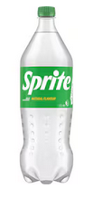  12 pack
- $6.20 for 280 g $9.40 for 460 g $7.30 for 350 g

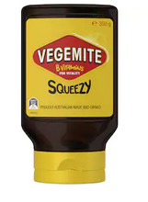


460g jar

Development
- Simplify to $ per unit and figure out the best buy.
- $3.24 for 6  $4.50 for 9  Second option | - 450 g to $4.05  0.7 kg to $6.16  Second option | - $5.40 for 12  $7.65 for 17  same
- 2 L for $5.60  6 x 375 mL for $6.12  First option | - 10 kg for $31  4 kg for $12.80  First option

- 2019 HSC Standard 2 Band 3
Sugar is sold in four different-sized packets. Which is the best buy?
- 100 g for $0.40
- 500 g for $1.65
- 1 kg for $3.50
- 2 kg for $6.90
B

- 2023 HSC Standard 2 Band 4
Four petrol pumps are shown, each with the amount of petrol purchased and its cost.
Which one represents the best value?
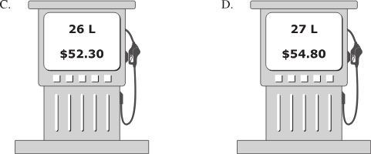
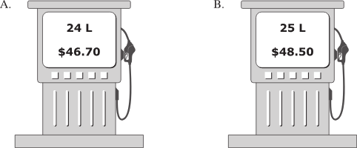

B
- HSC Sample Question Band 4
A brand of pasta is sold in two different packets.
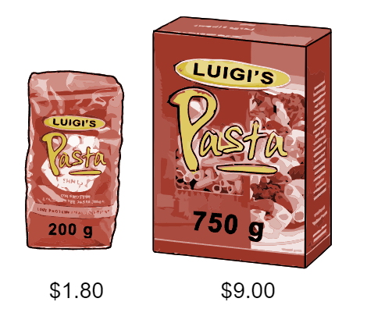
What is the difference in price per kg?

Option 1: $\frac{\$1.80}{200g}\frac{×5}{×5}=\frac{\$9}{1 kg}$
Option 2: $\frac{\$9}{750 g}\frac{÷3}{÷3}=\frac{\$3}{250 g}\frac{×4}{×4} =\frac{\$12}{1 kg}$
Difference is $3 / kg


- A bakery sells donuts in three packages:

4 for $1.55 6 for $2.30 10 for $3.75
Determine the best buy by:
  - Calculating the price of 1 donut for each option. Do not round your answer.

$0.3875 per donut | $0.38$\dot{3}$ per donut | $0.375 per donut
10 for $3.75 is the best buy
  - Calculating the cost of 60 donuts for each option.

$23.25 | $23 | $22.50
  - Why do you think 60 donuts was the number in part b?

It is the LCM of 4, 6, and 10

Mastery
- In a shop, potatoes are sold in 2 kg bags for $3.50.
In a wholesale market, potatoes are sold in 7 kg bags for $12.50.
For each option calculate:
  - The cost of 1 kg of potatoes.
Option 1  $1.75 / kg | Option 2  $1.79 / kg
  - The number of kilograms that can be bought for $1.
0.57 kg / $1 | 0.56 kg / $1
  - The cost of 14 kg of potatoes.
$24.50 / 14kg | $25 / 14kg
  - Determine the best buy.
Which method (a, b, or c) do you prefer to use for this question?

Option 1 is the best buy.

- The best buy is also the option with the highest units per dollar.
- A 2 kg box of sultanas for $8.85 or  a 1 kg box for $4.65  Option 1: $\frac{2 kg}{\$8.85}=\frac{0.2259887…kg}{\$1}$  Option 2: $\frac{1 kg}{\$4.65}=\frac{0.2150576…kg}{\$1}$  Option 1 is the best buy,  you get more per dollar. | - 45 g chips for $2.10 or 150 g for $6.50  Option 2

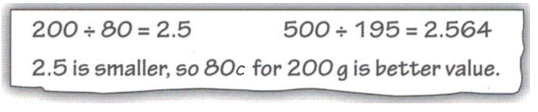
- Mario is doing his Maths homework. He needs to decide which is better value:
200 g of pasta for 80c or
500 g of pasta for $1.95
His working out is shown:
Explain why he is incorrect.

He did $\frac{Quantity}{Cost}$ , so he should choose the higher value.

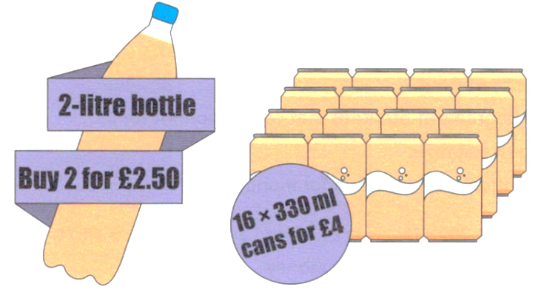
- A shop has these special offers. Which is the best buy? Explain your reasoning.

Bottles: 1.6 L per £1
Cans: 1.32 L per £1
Bottles are the best buy.
- Video games tend to use a secondary currency.
Round each option then determine the best buy.
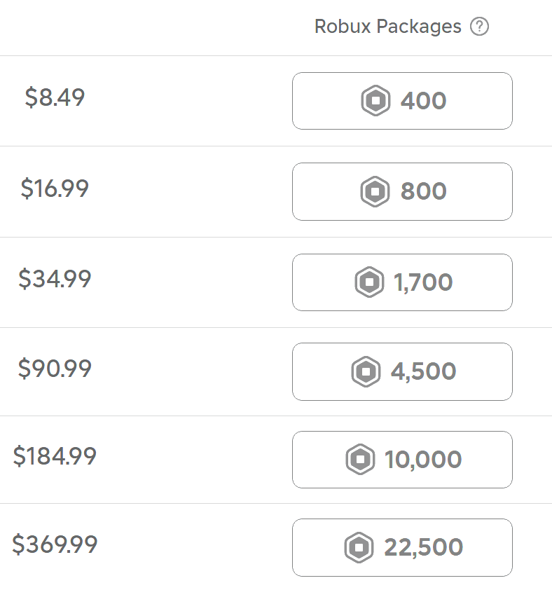

Best buy is 22 500 for $369.99
Explain why you shouldn’t always choose the option that is the best buy.

You are spending more money overall.

Rates Problems

- Review
- Solve these equations
- $\frac{x}{30}$ $=$ $\frac{12}{5}$ | - $\frac{360}{30}$ $=$ $\frac{x}{120}$ | - $\frac{240}{3}$ $=$ $\frac{2800}{x}$

- Set up equivalent rates equation
We can solve many problems by setting up an equation with equivalent rates.
We will focus on setting up the equation correctly.
6 kg costs $24  How much does 10 kg cost?  $$\frac{6 kg}{\$24}=\frac{10 kg}{\$x}$$ | 6 kg costs $24  How much can be bought for $40?  $$\frac{6 kg}{\$24}=\frac{x kg}{\$40}$$
Write the equivalent rate equation:
- 5 L of paint covers 28 m².  How much paint covers 70 m²?  $$\frac{5 L}{28 m^{2}}=\frac{ }{ }$$ | - 5 L of paint covers 28 m².  What area will 12 L cover?
- Sophie can type 450 words in 6 min.  How much time does she need to type 200 words? | - Sophie can type 450 words in 6 min.  How many words can she type in 5 minutes?
- 1.2 kg of fruit costs $9.60.  How much can you get for $12? | - A printer products 35 pages/min.  How long to print a 75 page booklet?
- Rates Problems
We can solve rates problems using equations and equivalent rates.
- Write the given information as an equation. Let the quantity you want to find be $x$.
- Solve for the unknown.
- If the unknown is in the denominator, take the reciprocal of both sides.

- Example Solve rates problems
A car travels 360 km on 30 L of petrol.  How far does it travel on 120 L?  1.  $$\frac{360 km}{30 L}=\frac{x km}{120 L}$$  2. $×120 ×120$  $$1440 km=x$$ | Bella can type 240 words every 3 minutes. How long does it take to write 2800 words?  1.  $$\frac{240 words}{3 min}=\frac{2800 words}{x min}$$  2. reciprocal both sides  $$\frac{3 min}{240 words}=\frac{x min}{2800 words}$$  $$×2800 ×2800$$  $35 min=x$

- Guided Practice
- $72 can buy 8 kg of chicken.  How much would 3 kg cost?  $$\frac{\$72}{8 kg}=\frac{\$ x}{3 kg}$$  $27 | - $5.50 can buy 0.5 kg of mince.  How much would 5 kg cost?  $$\frac{\$5.50}{0.5 kg}=\frac{ }{ }$$  $55
- One dozen (12) tennis balls cost $9.60. How much would 22 balls cost?  $$\frac{12 balls}{\$9.60}=\frac{22 balls}{\$ x}$$  $17.60 | - 3 pairs of socks cost $12.99.  How much would 10 pairs cost?  $$\frac{3 pairs}{\$12.99}=\frac{ }{ }$$  $43.30

- Key Ideas
- We can solve rates problems by setting up …………………… rates.
- If the unknown is in the denominator, we take the ………………… of both sides.

Foundation

- A truck uses 9 L of fuel per 100 km.  How many litres are needed for the truck to travel 28 km?  $$\frac{9 L}{100 km}=\frac{x L}{28 km}$$  2.52 L | - Perfume costs $157.90 for 50 mL.  How much does it cost for 80 mL?  $$\frac{\$157.90}{50 mL} =\frac{\$x}{80 mL}$$  $252.64
- Phillipa types at 75 words per minute.  How long would it take her to type a  500-word essay?  $$\frac{75 w}{1 min}=\frac{500 w}{x min}$$  $6.\dot{6}$ min | - 2 litres of paint cover 9 m².  How much paint is needed for 104 m²?  $$\frac{2 L}{9 m^{2}}=\frac{x L}{104 m^{2}}$$  $23.\dot{1}$ L
- A tap is dripping at a rate of 200 mL every 5 minutes.  How much water drips in 13 minutes?  $$\frac{200 mL}{5 min}=\frac{x mL}{13 min}$$  520 mL | - A snail travelling at a constant speed travels 400 mm in 8 minutes. How far does it travel in 7 minutes?  $$\frac{400 mm}{8 min}=\frac{x mm}{7 min}$$  350 mm
- A footballer scores an average of 4 goals every 6 games.  How many games would it take for him to score 20 goals?  $$\frac{4 goals}{6 games}=\frac{20 goals}{x games}$$  30 games | - A computer can process 500 megabytes of information in 4 seconds.  How long would it take to process 3700 megabytes?  $$\frac{500 MB}{4 s}=\frac{3700 MB}{x s}$$  29.6 s

- A car uses petrol at an average rate of 7.4 L/100 km. How much petrol will it consume in 58 km?

$$\frac{7.4 L}{100 km}=\frac{x L}{58 km}$$
4.292 L
- A dripping tap fills a 9-litre bucket in 3 hours. How long would it take to fill a 21-litre bucket?

$$\frac{9 L}{3 h}=\frac{21 L}{x h}$$
7 h
- Gemma runs 70 metres in 8.4 seconds.
If she maintains the same speed, in what time will she run 100 metres?

$$\frac{70 m}{8.4 s}=\frac{100 m}{x s}$$
12 s
- A factory produces 40 plastic bottles/minute.
How many bottles can the factory produce in 8 hours?

$$\frac{40 bottles}{1 min}=\frac{x bottles}{480 min}$$
19 200 bottles
- Daniel practises his guitar for 48 minutes every day.
How many days will it take him to log 10 000 hours of practice?

$$\frac{48 min}{1 day}=\frac{10 000 h}{x days}$$
$x=12500$ days
- Mr Ding is making cheesecake.
The recipe requires: 300 g cream cheese, 125 mL thickened cream.
Cream cheese only comes in 250 g packs so he bought 2 packs: 500 grams of cream cheese.
Mr Ding thought “If I’m increasing the amount of cream cheese by 200 g, then I should increase the amount of thickened cream by 200 mL, so I need 325 mL”
  - Describe what would happen to his cheesecake if he did this.

He is less-than-doubling the cream cheese but more-than-doubling the cream. It would be too runny.
  - How much thickened cream should he use for 500g of cream cheese?

$$\frac{300 g cheese}{125 mL cream}=\frac{500 g cheese}{x mL cream}$$
$x$ = 208.33 mL

Development
- Fertiliser is to be spread at the rate of 0.2 kg/m²
- How much fertiliser would be needed for an area of 600 m²?  $$\frac{0.2 kg}{1 m^{2}}=\frac{x kg}{600 m^{2}}$$  $x$ = 120 kg | - If the fertiliser is sold in 20 kg bags, how many bags are needed for an area of 600 m²?  120 kg ÷ 20 kg/bag = 6 bags | - What area could be fertilised with 1 t of fertiliser?  $$\frac{0.2 kg}{1 m^{2}}=\frac{1000 kg}{x m^{2}}$$  $$x = 5000 m²$$

- A car travels 800 km on a full tank of petrol.
The petrol tank holds 63 litres of petrol.
- Calculate the rate at which the car uses petrol, giving your answer in km per litre.  $$\frac{800 km}{63 L} = 12.7 km/L$$ | - Write the rate in L per 100 km.  $$\frac{63 L}{800 km}=\frac{x L}{100 km}$$  7.875 L per 100 km

- A car uses 9 L of petrol to travel 100 km. Answer to 1 d.p.
- How much petrol is needed to travel 50 km?  $$\frac{9 L}{100 km}=\frac{x L}{50 km}$$  $x$ = 4.5 L | - How far can it travel using 50 L?  $$\frac{9 L}{100 km}=\frac{50 L}{x km}$$  $x$ = 555.6 km

- A car uses 14 L of petrol to travel 147 km.
- How much petrol is needed to travel 100 km?  $$\frac{14 L}{147 km}=\frac{x L}{100 km}$$  $x$ = 9.52 L | - How far can it travel using 100 L of petrol?  $$\frac{14 L}{147 km}=\frac{100 L}{x km}$$  $x$ = 1050 km
- A car used 30 litres of fuel to travel 105 km. The fuel tank of the car has a capacity of 50 litres. Can the car complete a 180 km journey without refuelling?

$$\frac{30 L}{105 km}=\frac{x L}{180 km}$$
$x$ = 51.4 L
No, needs 51.4 L but tank only holds 50 L
- A person's heart beats at an average rate of 70 beats per minute.
- How many times will a heart beat in a lifetime of 80 years?  $$\frac{70 beats}{1 min}=\frac{70 beats}{1÷60÷24÷365 year}=\frac{36 792 000 beats}{1 year}$$  $$\frac{36 792 000 beats}{1 year}=\frac{x beats}{80 years}$$  = 2 943 360 000 beats | - How long will it take for a heart to beat  1 million times?  Give your answer in days, to 1 decimal place.  $$\frac{70 beats}{1 min}=\frac{1,000,000 beats}{x min}$$  $x$ = 14,285.7 min = 238.1 h = 9.9 days

- Anna is paid at the rate of $23.60/ h.
- How much would she be paid for working 15 h?  $$\frac{\$23.60}{1 h}=\frac{\$x}{15 h}$$  $354 | - How long would she need to work to earn $472?  $$\frac{\$23.60}{1 h}=\frac{\$472}{x h}$$  20 h
  - Anna wants to save for a trip. If she works 28 h in week 1, and 31 h in the next week,
how many more hours does she need to work to earn $2000?

Current earnings: (28 + 31) × $23.60 = $1392.40
Still needs: $2000 - $1392.40 = $607.60
Additional hours: $607.60 ÷ $23.60 = 25.7 h
- On a tin of paint, it states that you can cover 16 m² per litre. How many litres of paint do you need to cover a rectangular wall 5.2 m by 2.3 m if you need to apply three coats?

Wall area: 5.2 × 2.3 = 11.96 m²
Three coats: 11.96 × 3 = 35.88 m²
$$\frac{16 m^{2}}{1 L}=\frac{35.88 m^{2}}{x L}$$
$x$ = 2.24 L
- NAPLAN A+
One litre of soft drink contains 90 grams of sugar.
How many millilitres of soft drink contain 4.5 grams of sugar?

$$\frac{90 g}{1000 mL}=\frac{4.5 g}{x mL}$$
x = 50 mL
- 2023 HSC Standard 1
A tap is dripping at the rate of 4 mL per minute.
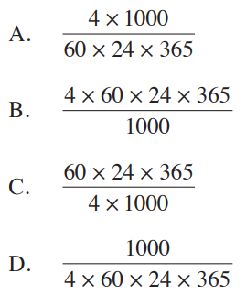
Which expression shows how many litres this would amount to in one year?

$$\frac{4÷1000 L}{1÷60÷24÷365 year}=\frac{4×60×24×365}{1×1000}$$
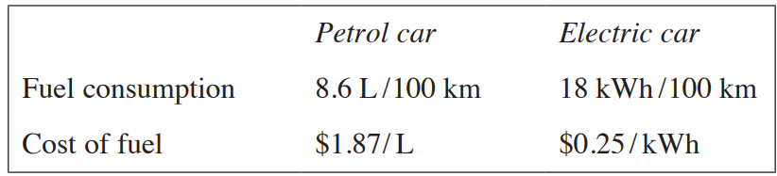
- 2023 HSC Standard 1

Jun travels on average 35 000 km per year.
How much will he save on fuel costs in a year by using an electric car?

$$Petrol:\frac{8.6 L}{100 km}=\frac{x L}{35000 km}, x = 3010 L$$
Cost: 3010 × $1.87 = $5628.70
$$Electric:\frac{18 kWh}{100 km}=\frac{x kWh}{35000 km}, x = 6300 kWh$$
Cost: 6300 × $0.25 = $1575
Savings: $5628.70 - $1575 = $4053.70

- The volume of water in a reservoir falls from 430 000 litres to 180 000 litres over 5 days.
  - Calculate the rate at which the reservoir is emptying, giving your answer in litres per day.

$$\frac{\left(430000 - 180000\right) L}{5 days} = 50000 L/day$$
  - Assume that the reservoir continues to empty at the same rate.
How many more days will it take for the reservoir to empty completely?

$$\frac{50000 L}{1 day}=\frac{180000 L}{x days}$$
$$x = 3.6 days$$
- A patient in hospital is given an antibiotic solution at the rate of 80 mL/ h.
- How much antibiotic solution will the patient receive in 6 $\frac{1}{2}$ h?  $$\frac{80 mL}{1 h}=\frac{x mL}{6.5 h}$$  $x$ = 520 mL | - How often would 600 mL containers of the antibiotic solution need to be changed?  $$\frac{80 mL}{1 h}=\frac{600 mL}{x hours}$$  Change every 7.5 hours
- If 1 mL of this solution contains 15 drops, calculate the rate at which the patient receives the antibiotic in drops/minute.

$$\frac{x drops}{1 min}=\frac{15 drops}{1 mL}×\frac{80 mL}{60 min}$$
20 drops/min

- The conversion rate for US dollars (US$) to Australian dollars (A$) is $0.65 US\$/ A\$$.
- How many US dollars would I receive for A$2750?  $$\frac{0.65 US}{1 A}=\frac{\$x US}{2750 A}$$  $1785.50 US | - How many Australian dollars would I receive for US$1300?  $$\frac{0.65 US}{1 A}=\frac{1300 US}{x A}$$  $2000 A | - Convert US$1800 into A$  $$\frac{0.65 US}{1 A}=\frac{1800 US}{x A}$$  $2769.23 A

Mastery
- Ruth’s tropical fish are breeding at a rate of 8 new fry every 2 days per female fish.
If Ruth has a total of 9 female fish, then how long will it take them to birth a total of 90 new fry?

8 new fry/ 2 days = 4 new fry / day
For 9 female fish, 36 new fry / day
$$\frac{36 fry}{1 day}=\frac{90 fry}{x days}$$
2.5 days
- Two cars travel toward each other on a 100 km straight stretch of road.
They leave at opposite ends of the road at the same time.
The cars’ speeds are 100 km/h and 80 km/h.
How long does it take for the cars to pass each other?
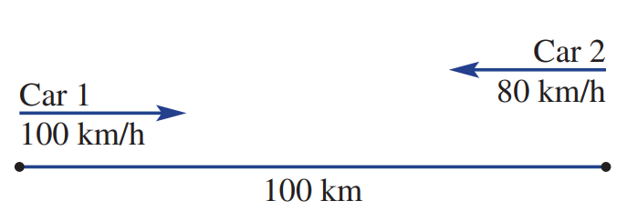

We will use a physical principle called relative velocity to solve this.
Consider being the driver in Car 2. From your perspective, car 1 is travelling towards you at 180 km/h
You will meet after:
$$t=\frac{d}{s}=\frac{100 km}{180 km/h}≈0.555…h=33\min{20}sec$$

- A river is flowing downstream at a rate of 1 km/h.
In still water Portia can swim at a rate of 2 km/h.
Portia dives into the river and swims downstream, then turns around and swims back to the starting point, taking 0.5 hours in total.
How far did she swim?

Downstream speed: 2 + 1 = 3 km/h
Upstream speed: 2 - 1 = 1 km/h
Let distance swum = d km
Time downstream + Time upstream = 0.5 h
Using $t=$ $\frac{d}{s}$
$$\frac{d}{3}+\frac{d}{1}= 0.5$$
$$\frac{4d}{3}= 0.5$$
$$d = 0.375 km$$
Total distance swum = 2d = 0.75 km = 750 m

- Electric cars use on average 17 kWh per 100 km. Electricity costs $0.28 per kWh.
Petrol cars use on average 9 L per 100 km. Petrol costs $1.98 per litre.
The electric car costs on average $10 000 more than a petrol car.
How far do you have to drive the electric car until you start to save money?

Electric cost per 100 km: 17 × $0.28 = $4.76
Petrol cost per 100 km: 9 × $1.98 = $17.82
Savings per 100 km: $17.82 - $4.76 = $13.06
Distance needed: $10000 ÷ $13.06 per 100 km = 76,570 km

Converting Units of Speed

- Speed
Speed is a rate that relates distance and time.
$$speed=\frac{distance}{time}$$
To convert units of speed:
- Write the rate as a fraction with units.
Numerator is the first quantity. Denominator is 1.
- Convert the quantities to the required units.
- Simplify the fraction using a calculator.

- Example Convert units of speed
Convert 60 km/h to m/s  1. $\frac{60 km}{1 hr}$ $=$ $\frac{\left( \right) m}{\left( \right) s}$2. $=$ $\frac{\left(60×1000\right) m}{\left(1×60×60\right) s}$3. $=$ $\frac{16.6\dot{6} m}{1 s}$  $16.6\dot{6} m/s$ | Convert 12 m/s to km/h  1. $\frac{12 m}{1 s}$ $=$ $\frac{\left( \right) km}{\left( \right) h}$2. $=$ $\frac{\left(12÷1000\right) km}{\left(1÷60÷60\right) h}$3. $=$ $\frac{43.2 km}{1 h}$  $43.2 km/h$

- Guided Practice
Convert these units of speed.
- Convert 75 km/h to m/s  $$\frac{75 km}{1 hr}=\frac{ m}{ s}$$  $=$  $20.8\dot{3}$ m/s | - Convert 5 m/s to km/h  18 km/h
- Convert 40 km/h to m/s  $11.\dot{1}$ m/s | - Convert 900 km/h to m/s  250 m/s
- Convert 300 000 m/s to km/h  1 080 000 km/h | - Convert 100 m / 9.58 s to km/h  37.58 km/h

Foundation
- Convert these units of speed to metres per second.
- 70 km/h  $19.\dot{4}$ m/s | - 45 km/h  12.5 m/s | - 76 km/h  $21.\dot{1}$ m/s | - 40 km/h  $11.\dot{1}$ m/s

- Convert these units of speed to kilometres per hour.
- 8 m/s  28.8 km/h | - 15 m/s  54 km/h | - 12.5 m/s  45 km/h | - 25 m/s  90 km/h


- Amy notices a pattern:
To convert from m/s to km/h, multiply by 3.6
To convert from km/h to m/s, divide by 3.6

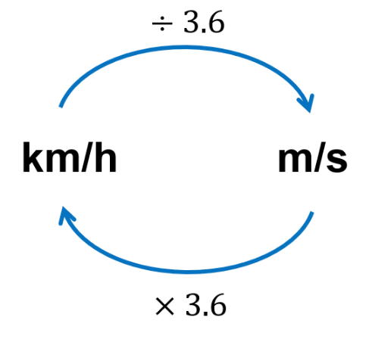
Convert these speeds using the rule.

- 40 km/h to m/s  $11.\dot{1}$ m/s | - 80 km/h to m/s  $22.\dot{2}$ m/s | - 65 km/h to m/s  $18.0\dot{5}$ m/s
- 10 m/s to km/h  $36$km/h | - 6 m/s to km/h  $21.6$ km/h | - 18.5 m/s to km/h  $66.6$ km/h
- 85 km/h to m/s  $23.6\dot{1}$ m/s | - 120 km/h to m/s  $33.\dot{3}$ m/s | - $8.\dot{6}$ m/s to km/h  $31.2$ km/h
- 50 km/h to m/s  $13.\dot{8}$ m/s | - 40 m/s to km/h  144 km/h | - 100 km/h to m/s  $27.\dot{7}$ km/h

Decimal and Sexagesimal Time

- Review
- 30 min the same as 0.3 hours?
- 30 minutes in hours, as a decimal.
- How many minutes will 0.3 hours be, approximately?

- Sexagesimal Time
Our number system is called the decimal system based on tens.
- Ten ones are ten. Ten tens are a hundred. Ten hundreds is a thousand…
Time uses the sexagesimal system, based on sixties.
- Sixty seconds are a minute. Sixty minutes are an hour.
Convert between decimal form and sexagesimal form by using the buttons:


or
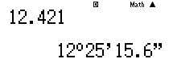

Hours
Minutes
Seconds

- Convert time to decimal form

Convert 2 hours 37 minutes to decimal form

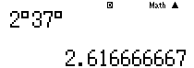
$2$ hours $37$ minutes $=2.61\dot{6}$ hours.

Convert these times to hours in decimal form using a calculator.
  - 2 hours 30 minutes  2.5 hours | - 4 hours 15 minutes  4.25 hours | - 0 hours 45 minutes  0.75 hours
- 1 hour 33 minutes  27 seconds  1.5575 hours | - 13 minutes  25 seconds  $0.2236\dot{1}$ hours | - 7 hours 16 minutes  44 seconds  $7.27\dot{8}$ hours

- Convert time to sexagesimal form
Convert 3.27145 hours to hours, min, sec.

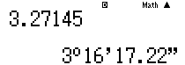

3.27145 hours $=$ 3 hours 16 min 17.22 sec

Convert these times to hours, minutes, and seconds using a calculator.
- 2.75 hours  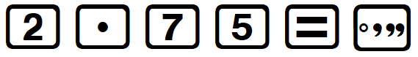  2 h 45 m | - 3.5 hours  3 h 30 m | - 3.3 hours  3 h 18 m
- 15.282 hours  15 h 16 m 55.2 s | - 0.281 hours  16 m 51.6 s | - $2.\dot{6}$ hours  2 h 40 m

- Key Ideas
- There are two ways to write time: as a d………………… or s……………………

Foundation
- Convert these times to hours in decimal form using the sexagesimal button on a calculator.
- 0 hours 30 minutes  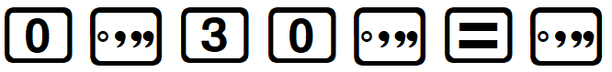  0.5 h | - 0 hours 15 minutes  0.25 h | - 0 hours 20 minutes  $0.\dot{3}$ h
- 1 hour 40 minutes  $1.\dot{6}$ h | - 1 hour 45 minutes  1.75 h | - 245 minutes  $4.08\dot{3}$ h
- 3 hours 40 minutes  $3.\dot{6}$ h | - 5 hours 10 minutes  $5.1\dot{6}$ h | - 128 minutes  $2.1\dot{3}$ h
- 2 hours 35 minutes  48 seconds  $2.59\dot{6}$ h | - 25 minutes  13 seconds  $0.4203$ h | - 12 hours 6 minutes  4 seconds  $12.10\dot{1}$ h

- Convert these to hours, minutes, and seconds using the sexagesimal button on a calculator.
- 1.3 hours    1 h 18 min | - 1.5 hours  1 h 30 min | - 0.25 hours  0 h 15 min
- 0.2 hours  0 h 12 min | - 1.6 hours  1 h 36 min | - 1.875 hours  1 h 52 m 30 s
- 8.125 hours  8 h 7 m 30 s | - $0.\dot{6}$ hours  0 h 40 min | - $9.\dot{1}$ hours  9 h 6 m 40 s
- $2.3\dot{6}$ hours  2 h 22 min | - 7.15 hours  7 h 9 min | - 0.7$\dot{6}$ hours  0 h 46 min

Calculating Speed Distance Time

- Speed Formulas
$$Speed=\frac{Distance}{Time}$$ | $$Distance=Speed×Time$$ | $$Time=\frac{Distance}{Speed}$$
1. Write the formula
2. Substitute

- Example Calculate speed, distance, time
Worked example | Your Turn
A plane travels 2800 km in 4 hours.  Calculate its speed in km/h.  1. $s=$ $\frac{d}{t}$2. $=$ $\frac{2800}{4}$ $=$ $\frac{700 km}{1 h}$  $=$ 700 km/h | A car travelled 600 km in 12 hours.  Calculate its speed in km/h.  $50$ km/h
A car travels at 60 km/h for 2.5 hours.  How far does it travel?  1. $d=st$2. $=$ $60×2.5$  $=150$ km | A car travels at 55 km/h for 3.75 hours.  How far does it travel?  206.25 km
A plane is flying from Sydney to Singapore at a speed of 800 km/hr. How long will it take to get there if the two cities are 6300 km apart?  1. $t=$ $\frac{d}{s}$2. $=$ $\frac{6300}{800}$ $=7.875 hours$ $=7 h 52\min{30}s$ | A train is travelling from Central to Blacktown at a speed of 80 km/h. How long would the journey take if the stations are 45 km apart?  33 minutes 45 seconds

Foundation
- Complete the table
Speed  $$s=\frac{d}{t}$$ | Distance  $$d=st$$ | Time  $$t=\frac{d}{s}$$
52 km/h | 104 km | 2 hours
17 km/h | 51 km | 3 hours
62 km/h | 248 km | From 10:30 am to 2:30 pm
300 km/h | 750 km | $2$ $\frac{1}{2}$ hours
6 km/h | 7.5 km | $1$ $\frac{1}{4}$ hours
45 km/h | 90 km | 2 hours
60 km/h | 180 km | 3 hours
5.5 km/h | 22 km | 13:00 to 17:00
10 km/h | 15 km | $1$ $\frac{1}{2}$ hours
52 km/h | 26 km | 07:52 to 8:22
3 km/h | 12 km | 4 h
11 km/h | 55 km | 5 h
7 km/h | 21 km | 3 h
400 km/h | 1000 km | 2.5 h
18 km/h | 10 km | $0.\dot{5}$ h or 33 m 20 s

- Find the average speed in km/h of a vehicle that travels:
- 180 km in 2 hours  90 km/h | - 485 km in 5 hours  97 km/h | - 360 km in 4.5 hours  80 km/h
- 21 km in $\frac{1}{4}$ hour  84 km/h | - 240 km in $2\frac{1}{2}$ hours  96 km/h | - 16 km in 20 minutes  48 km/h

Development
- Find the distance in km travelled by a car with these average speed and time.
- 3 h 30 min at 64 km/h  224 km | - 3 h 20 min at 56 km/h  $186.\dot{6}$ km | - 5 h 47 min at 82 km/h  $474.2\dot{3}$ km
- 2 h 13 min at 75 km/h  166.25 km | - 2 $\frac{3}{4}$ hours at 56 km/h  154 km | - 3 $\frac{1}{2}$ hours at 82 km/h  287 km

- How long will it take to travel these distances? Answer to the nearest minute.
- 160 km at 80 km/h  2 h | - 150 km at 60 km/h  2 h 30 min | - 120 km at 50 km/h  2 h 24 min
- 225 km at 45 km/h  5 h | - 240 km at 40 km/h  6 h | - 80 km at 95 km/h  51 min

- Caitlin lives in Wollongong and travels to Sydney daily.
The car trip requires her to travel at different speeds.
She travels 30 kilometres at 60 km/h and 40 kilometres at 100 km/h.
  - What is the total distance of the trip?
70 km
  - How long (in hours) does the trip take?

0.9 h
  - What is her average speed (in km/h) when travelling to Sydney?
Find average speed by dividing total distance by total time.
Answer correct to two decimal places.

$77.\dot{7}$ km/h

- Calculate the unknown quantity in each of these scenarios.
Round to 2 decimals for distance show the seconds for time.
- Find the average speed (in km/h) of a vehicle that travels 500 km in 6 hours and 10 minutes.  81.08 km/h | - Find the distance travelled by a car whose average speed is 68 km/h if the journey lasts 1 hour 20 minutes.  90.67 km | - How long will it take a vehicle to travel 50 km at a speed of 60 km/h?  50 min
- Find the average speed (in km/h) of a vehicle that travels 36000 m in 45 minutes.  48 km/h | - How long will it take a vehicle to travel 15 km at a speed of 40 km/h?  22 m 30 s | - Find the distance travelled by a car whose average speed is 70 km/h if the journey lasts 50 minutes.  58.33 km

- The land speed record is 20.4 km/min.
  - Express this speed in km/h.
1224 km/h
  - How far does this vehicle travel in 5 minutes?
102 km
  - How far does this vehicle travel in 1 second?
0.34 km
  - How long would it take for this vehicle to travel from Sydney to Brisbane (982 km)?
Answer to the nearest minute.

48 min

Mastery

  - The first automobile, developed in 1886, could reach a speed of 16 km/h.
Calculate the time taken to travel 1228 km at this speed, to the nearest minute.

76 h 45 m
  - Thrust SuperSonic Car is the fastest land vehicle. It can travel at a speed of 1228 km/hr. Calculate the time taken to travel 16 km at this speed.

47 s

- The distance from Broken Hill to Tibooburra is 360 km. A motorist travels from Broken Hill to Tibooburra at a mean speed of 90 km/h and returns at a mean speed of 60 km/h.
What is the average speed of the motorist for the whole journey?

72 km/h
- Brothers Marco and Matthew start riding from home into town, which is 30 km away.
Marco rode at 10 km/h and Matthew took 20 minutes longer to complete the trip.
Assuming that they both rode at a constant speed, how fast was Matthew riding?

9 km/h
- Shari travels at 50 km/h for 10 km. For the next 10 km she wants to drive fast enough to make her average speed 100 km/h over the 20 km trip.
Advise Shari about reaching this average speed.

For 100 km/h over 20 km, she must complete the whole journey in 20 minutes.
She has already spent 20 minutes to travel 10 km at 50 km/h, so it is impossible.
- A satellite has a circular orbit 800 km above the Earth’s surface.
  - If the radius of the Earth is 6400 km, find the radius of the orbit of the satellite.

7200 km
  - Find the circumference of the satellite’s orbit, to the nearest kilometre.

45 239 km
  - If the satellite makes one orbit in a day, find the speed of the satellite.

1885 km/h

Interpreting Distance-Time Graphs

- Distance Time Graphs
- Distance Time Graphs 1: https://www.geogebra.org/m/ncm9gzch
- Distance Time Graphs 2: https://www.geogebra.org/m/nn4q6ehs
- Distance Time Graphs 3: https://www.geogebra.org/m/akbvuhuc
A distance-time graph shows a journey.
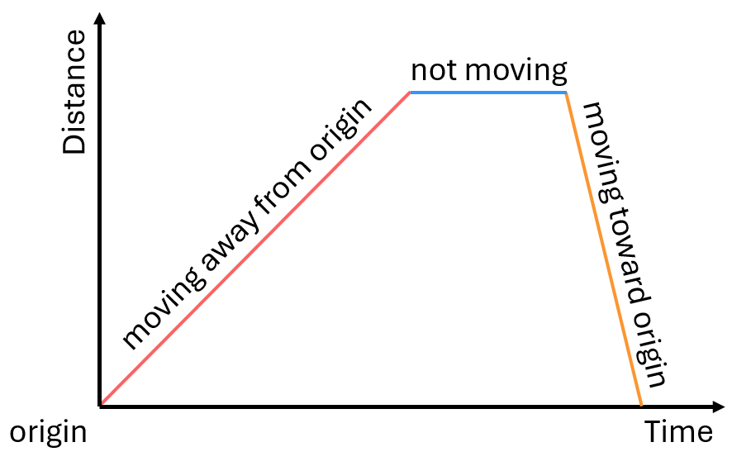

The greater the speed, the steeper the line.
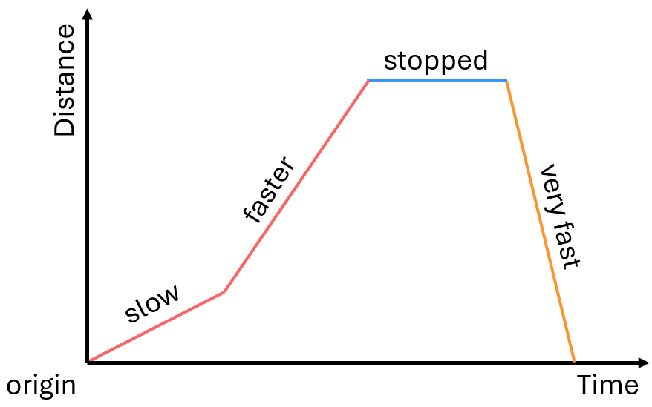

- Interpret Distance-time Graphs
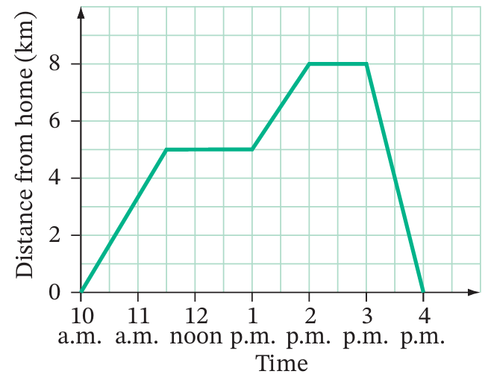
The distance time graph shows Bella’s bushwalk.
She:

- Hiked for a while
- Stopped to eat lunch
- Continued her journey
- Stopped at the lookout
- Then quickly returned

How far did Bella travel from 1 pm to 2 pm?

When was Bella’s lunch break?

How long did she spend eating lunch?

When did she arrive home?

The graph shows the journey of a car travelling from home to a worksite and back.
Before reaching the worksite, the car briefly stopped to refuel.
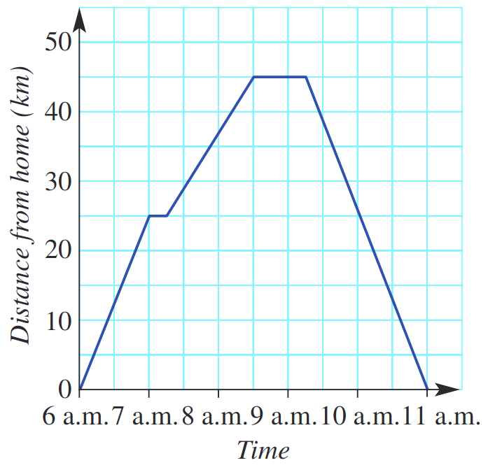
How far is the worksite from home?

45 km
When did the car stop to refuel?
7 am
How long was the refuelling stop?
15 minutes
How long did the car stop at the worksite?
45 min
How long did the return journey take?
1 h 45 min

- Key Ideas
- Distance – time graphs show a ……………………………
- The faster the speed, the ………………………… the slope.
- When the line is horizontal, the object is ……………………………

Foundation
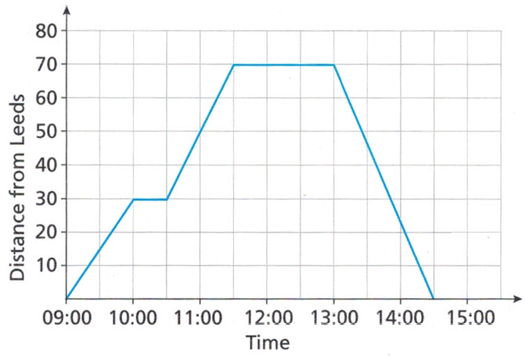
- Marta drove from Leeds to Liverpool to deliver a parcel, and then she returned home.
The graph shows her journey.

  - Marta stopped at a service station on the way to Liverpool.
When did she stop and for how long did she stop?
10:00 for 30 min
  - How far is the service station from Leeds?
30 km
  - How far is the service station from Liverpool?
70 – 30 = 40 km

- This graph shows Emily’s journey to the gym.
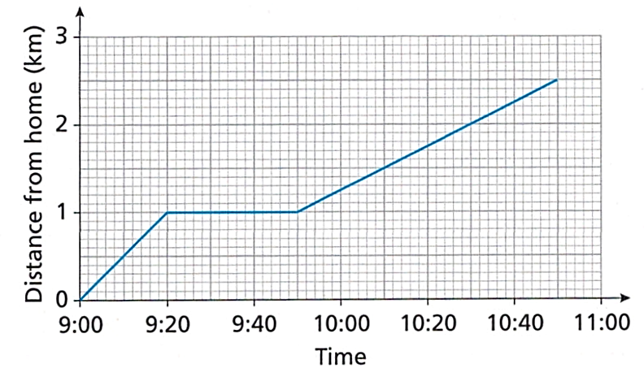

  - After walking 1km, Emily stopped to pick up her friend Ed, but he wasn't ready.
How long did she have to wait for Ed?
30 min
  - How long did it take Emily and Ed to walk the rest of the way to the gym?
60 min
  - Did Emily walk faster when she was on her own or when she was with Ed?
Explain your answer.
On her own. The graph is steeper when Emily was on her own.

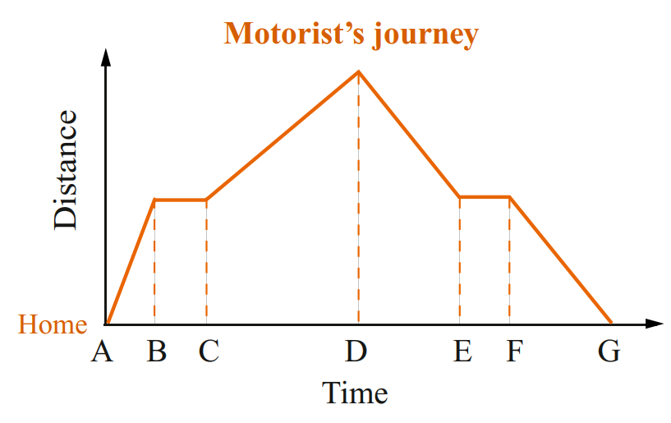
- The graph shows the journey of a motorist.

State the time intervals that represent these situations.
  - The motorist was stationary (stopped).
BC and EF
  - The motorist was travelling the fastest.
AB
  - The motorist was travelling the slowest.
CD
  - The motorist’s distance from home was increasing.
AB, CD
  - The motorist’s distance from home was decreasing.
DE, FG

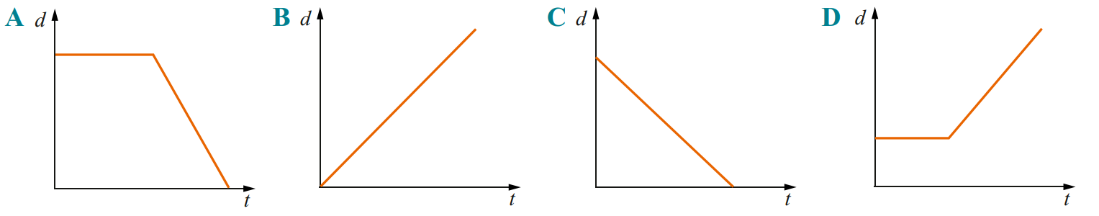
- Match each of these descriptions to one of the graphs below.

  - I left home and travelled at a constant speed for the entire journey.
B
  - I returned home travelling at a constant speed.
C
  - I waited for my friend to arrive, then we travelled home at a constant speed.
A
  - I waited for my friend to arrive, then we completed the journey at a constant speed
D

Development
- Match each of these descriptions to one of the graphs shown.
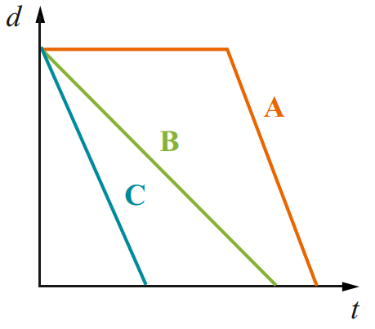
  - Ashya left school and walked home.
B
  - Her brother Rob left at the same time and rode his bike home.
C
  - Their sister Jane talked to a friend for a short time and
then caught the bus home from school.
A
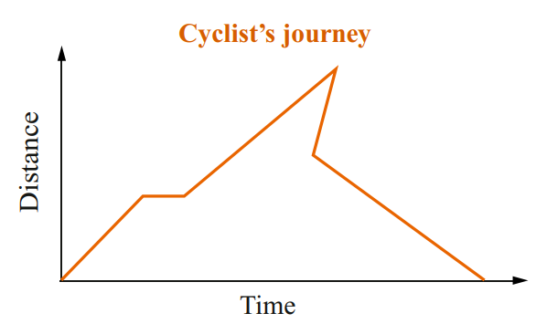
- Pete drew the distance–time graph shown to represent a trip made by a cyclist.

Explain why Pete’s graph is not possible.
There is an interval where the cyclist is going back in time.

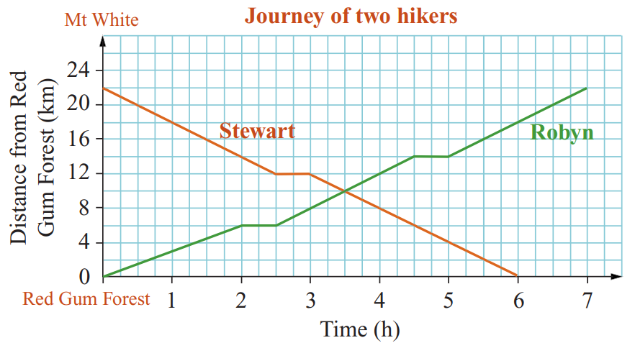
- The graph shows the journeys of two hikers, Robyn and Stewart.
Robyn starts at Red Gum Forest and walks to Mount White.
Stewart starts at Mount White and walks to Red Gum Forest along the same track.

  - Who completed the hike in the least time?
Stewart
  - When did Robyn and Stewart pass each other?
After 3.5 hours
  - At this time, how far was each hiker from their destination?
Stewart: 10 km, Robyn: 12 km
  - How far apart were they after 3 hours?
4 km
  - How far did Robyn still have to travel when Stewart arrived at Red Gum Forest?
4 km
- Match the distance time graphs to the description of the journey.
Journey A: A man walks slowly away from home, stops for a short time, then continues walking away from home at a fast pace and finally stops again.
Journey B: A girl walks slowly away from home and then stops for a short time.
She then turns around and walks at a fast pace back to her home.
Journey C: A boy walks quickly away from home, briefly stops, then continues slowly walking away from home and finally stops again.
Journey D: A woman walks quickly away from home and then stops briefly.
She then turns around and slowly walks back home.
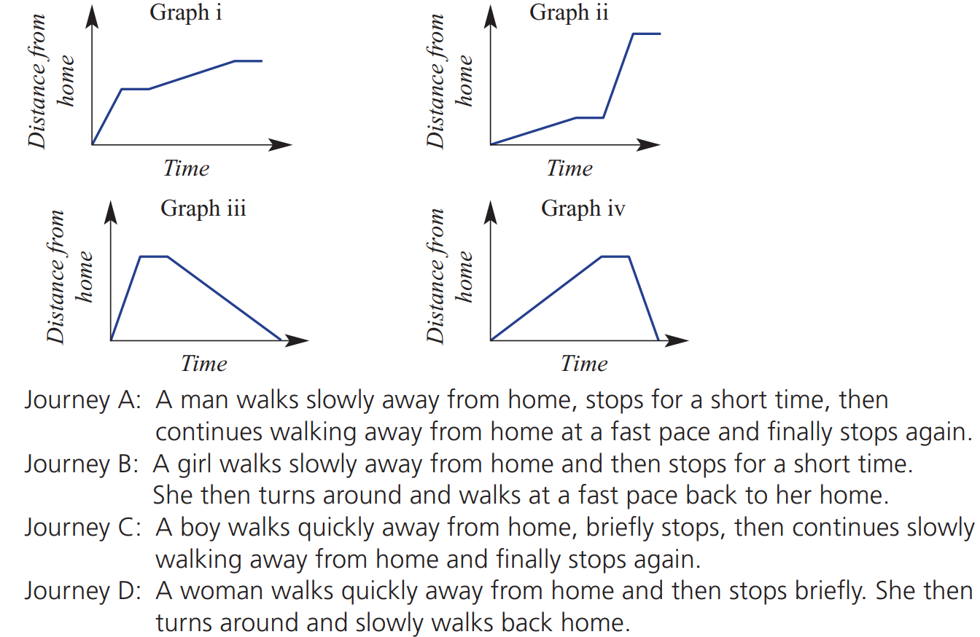  C | A
D | B
- Match the distance time graphs to the description of the journey.
Journey A: Susan takes 1 hour to cycle 10 km towards home.
She then cycles 5 km away from home in 1 hour and then rests for 1 hour.
Journey B: Susan takes 1 hour to cycle 10 km towards home.
She stops to rest for an hour and then cycles another 10 km home in 1 hour.
Journey C: Susan takes 1 hour to cycle 10 km away from home.
She stops to rest for an hour and then cycles back home in 1 hour.
Journey D: Susan takes 1 hour to cycle 10 km away from home.
She stops to rest for an hour and then cycles 10 km further in 1 hour.
D | 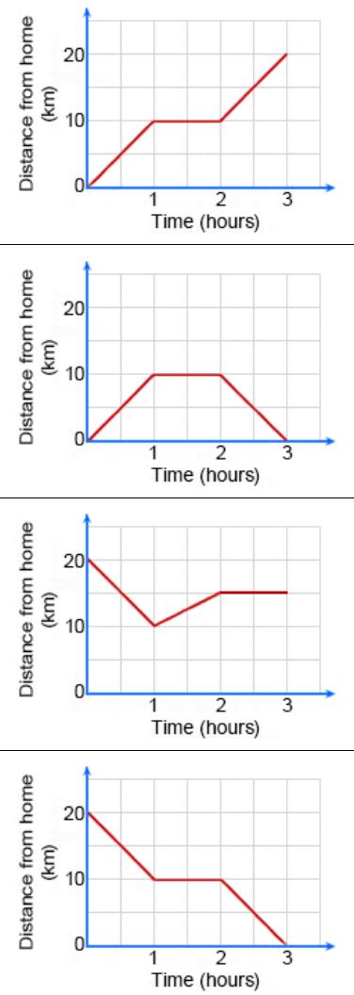  C
A | B

Mastery
- 2022 HSC Standard 1
The travel graph displays Jamie’s trip which began at town M at 8 am and finished at town N.
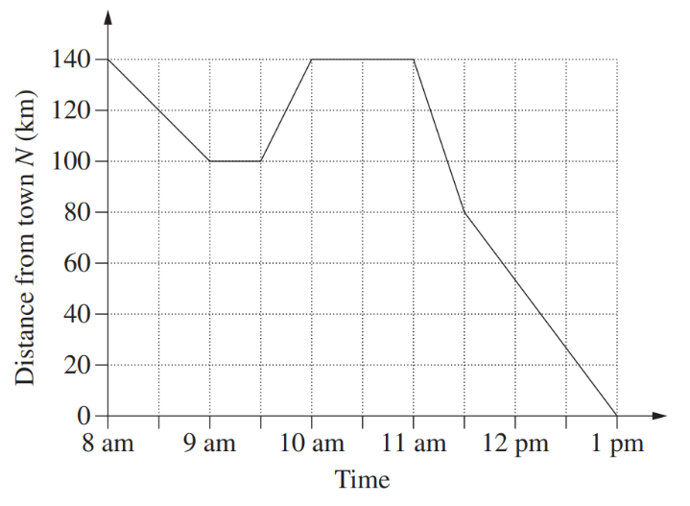
  - How far apart are the two towns?
140 km
  - At what time during the day did Jamie arrive back at town M?
10 am
  - What was the total distance that Jamie travelled?
40 + 40 + 140 = 220 km
  - Between which times in the day was Jamie travelling at the fastest speed?
Justify your answer, without calculations.
11:00 to 11:30. This is the steepest segment.

- Mr Ding’s parents wanted him to go to a good school, so he had to travel a long distance.
Draw a distance-time graph of his journey from home to school using this information:
- Mr Ding leaves home at 7:10 am.
- He walks 20 minutes to Burwood station, a distance of 2 km.
- He takes the 7:30 am train to Epping.
The train journey takes 20 minutes and covers a distance of 15 km.
- He waits for 10 minutes at Epping for the bus.
- The bus arrives at school at 8:35 am and travels a distance of 8 km.

Calculating Speed in Distance-Time Graphs

- Speed on a distance-time graph
Since speed is $\frac{change in distance}{change in time}$, we calculate speed from a distance-time graph by doing:
$$speed=\frac{change in y}{change in x}$$
So, speed is the gradient of the line segment.

- Calculate speed from a distance-time line segment
Calculate the speed from the distance-time graph.
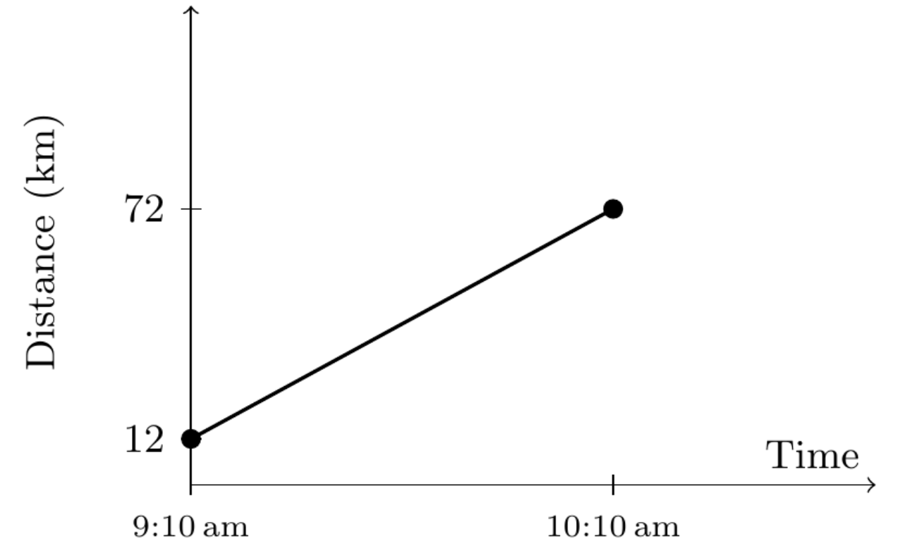 | 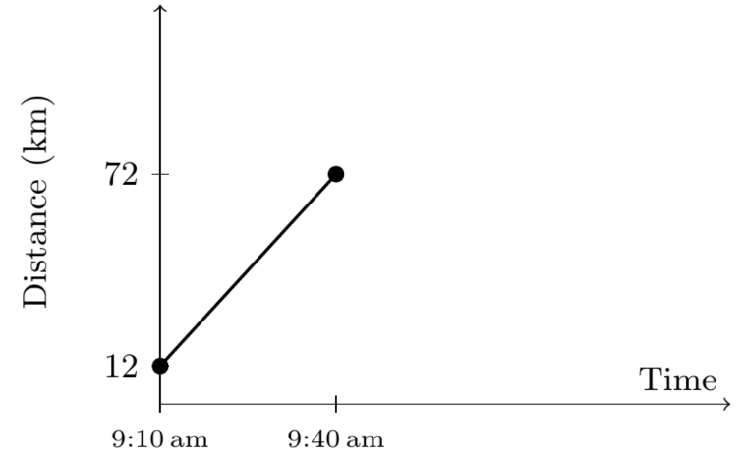 | 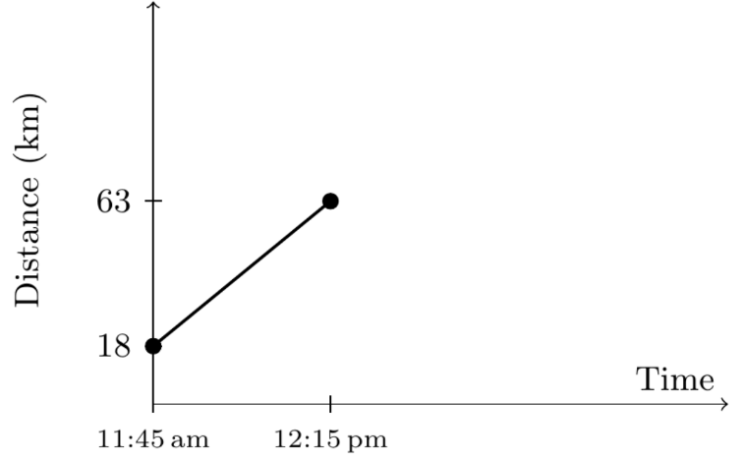
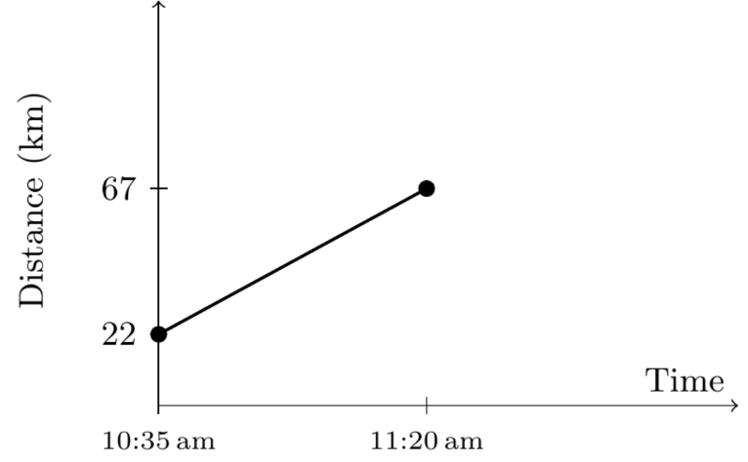 | 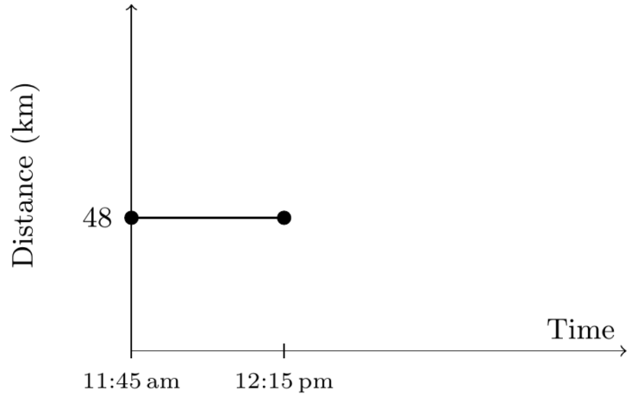 | 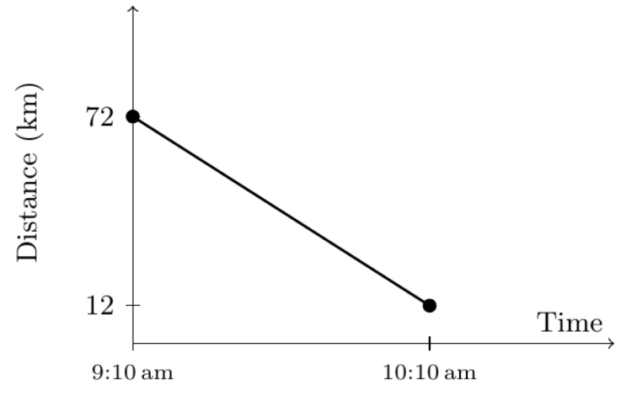
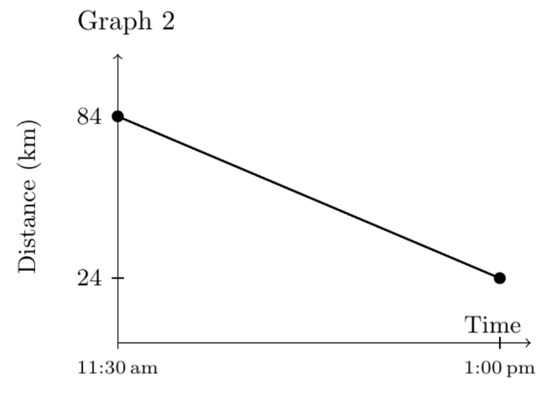 | 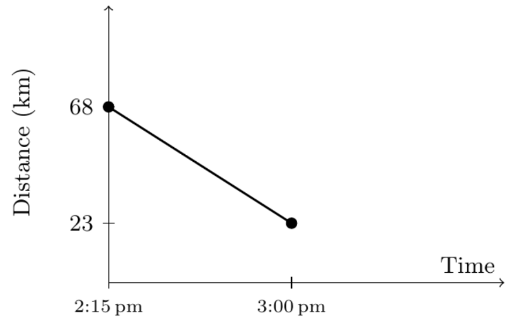 | 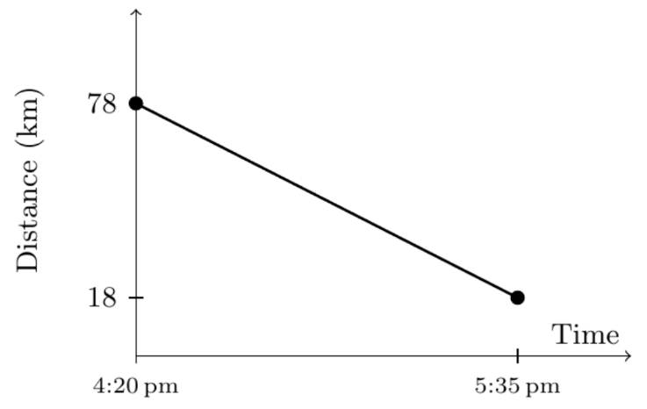
- Example Calculate speed from a distance-time graph
The distance time graph shows the journey of Bella’s bushwalk along a hiking trail.
What was her speed during the first leg of her
journey between 10 am and 11:30 am?
$$speed=\frac{distance}{time} \\ =\frac{5 km}{1.5 h}$$ $=3.33$km/h
What was her speed during the second leg of the journey?
$$speed=\frac{8-5 km}{1 h}$$ $=3$ km/h

- Guided Practice
The distance time graph shows the journey of Ben’s bushwalk
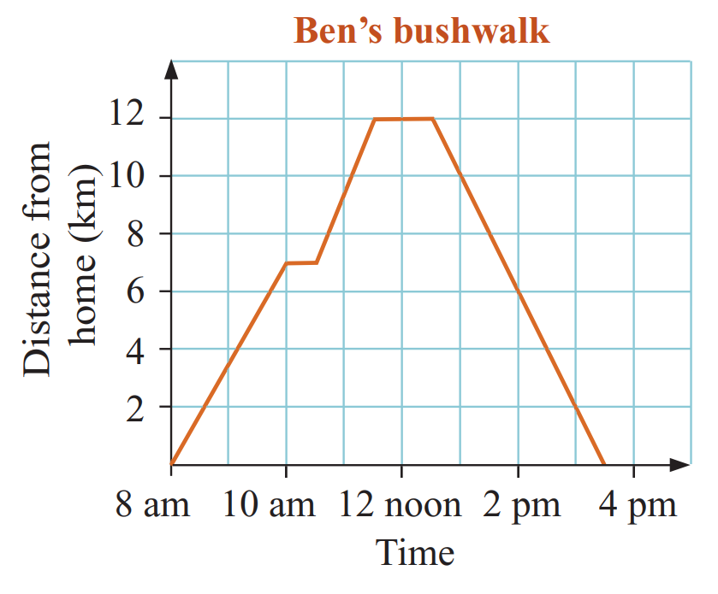
What was Ben’s speed during:
  - the first leg of his journey?

3.5 km/h
  - during the second leg of his journey?

5 km/h
  - during the return trip?

4 km/h
  - What was Ben’s average speed for the entire journey, including the stops?

3.2 km/h

Foundation
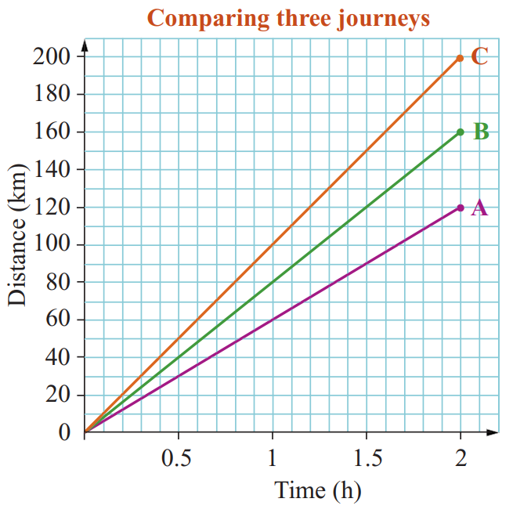
- Three motorists set out from the same starting point at the same time. The graph shows the distance of each motorist from the starting point for the first 2 hours of their trip.
  - Which line is the steepest?
C
  - Calculate the speed of each motorist
C: $\frac{distance}{time}$ $=$ $\frac{200}{2}$ $=$ ……… km/h
100 km/h
B: ………………………………………………
80 km/h
A: ………………………………………………
60 km/h
  - The steeper a line is on a distance–time graph,
the ………………… the speed of the vehicle.
faster
  - Another motorist starts at the same point and travels at 50 km/h for 2 hours.
    - Draw the straight-line graph of this journey on the axis above.
The line should start from (0,0) and end at (2,100)
    - Describe the steepness of this line compared to the others, how does this relate to the speed?
It is the least steep as it is the slowest speed.
- 2023 HSC Standard 1
The graph shows the first two stages of a car journey from home to a holiday house.
  - At what speed, in kilometres per hour, did the car travel during stage A of the journey?
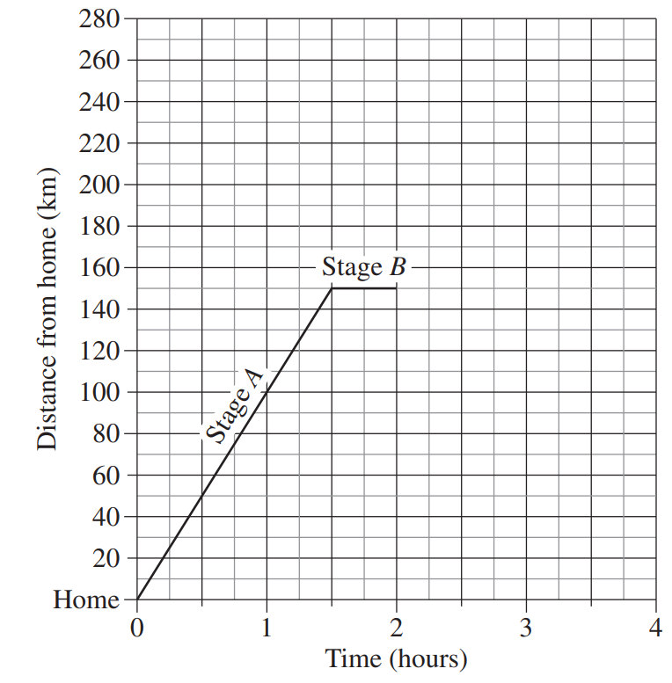

150 km/h in 1h 30 min = 100 km/h
  - For how long did the car stop during
stage B of the journey?

30 min
  - After stage B, the car continues to travel towards the holiday house at a constant speed of 50 km/h for 2 hours.
Graph this part of the journey on the grid.

Straight line connecting (2,150) to (4,250)

- Three cyclists, Jim, Sam and Ben, set out from the same starting point to travel home.
The graph shows the distance from home of each cyclist for the first 2 hours of their journey.
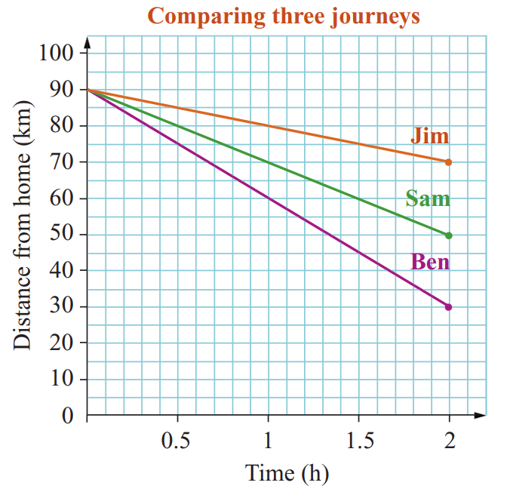
  - How far from home did the cyclists start?
90 km
  - How far was Jim from home after 1 hour?
80 km
  - When was Sam 80 km from home?
After 30 min
  - How long did it take Ben to travel 45 km?
1 h 30 min
  - Which line is the steepest?
Ben’s journey
  - Calculate the speed of each cyclist

Jim: Sam: Ben:
Jim: 10 km/h, Sam: 20 km/h, Ben: 30 km/h
  - Another cyclist starts at the same point and travels at 15 km/h for 2 hours.
Describe the line for this cyclist.
Steeper than Jim but less steep than Sam.

- Faith travelled 240 km to visit her father.
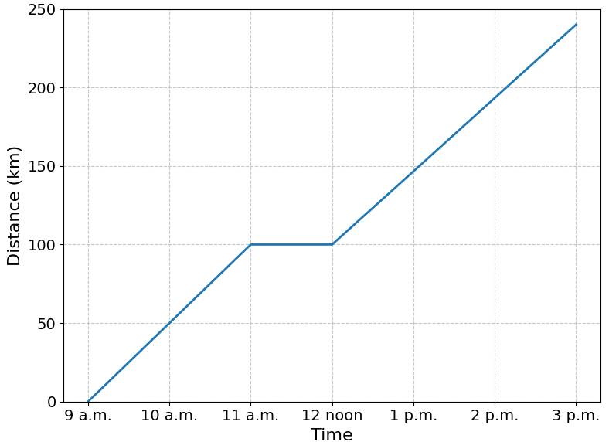
  - Faith made one stop on the journey.
For how long did she stop?
1 h
  - Find Faith's average speed between 9 a.m. and 3 p.m, including her stop.

240 $÷$ 6 = 40 km/h
  - What was Faith's speed between 9 a.m. and
11 a.m.?

50 km/h
  - What was Faith's speed between 12 noon and 3 p.m.?

$46.\dot{6}$ km/h
  - Find Faith's average speed for the time she was actually driving, not including her stop.

240 $÷$ 5 = 48 km/h

Development
- This graph shows the journey of a car to a worksite and back.
Before reaching the worksite, the car made a small stop at a petrol station.
  - Label the line segments as:
A: Before petrol station
B: After petrol station but before worksite
C: Return from worksite
  - What was the car’s speed during stage A?
25 km/h
  - What was the car’s speed during stage B?
16 km/h
  - What was the car’s speed during stage C?
$25.71$ km/h
  - What distance did the car travel in total?
90 km
  - What was the car’s average speed for the whole journey, not including the stops?
90 $÷$ 4 = 22.5 km/h

- The graph shows Flo and Chloe’s journeys as they drove from home.
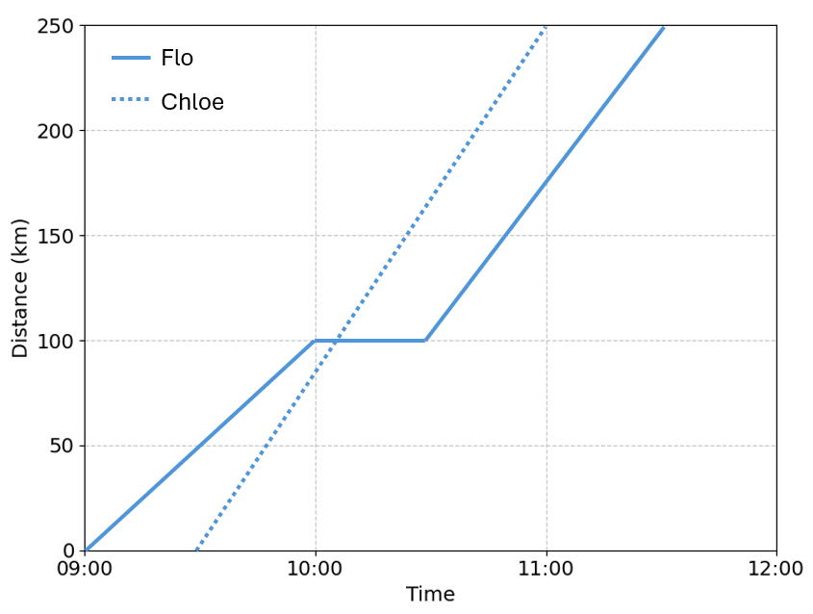
  - Explain how the graph shows that Chloe drove at a constant speed for the whole journey.

Her line is a straight line with constant steepness.
  - Calculate Chloe’s speed,
round to one decimal place.

250 $÷1.5$ = $166.7$ km/h
  - Flo stopped to fix a puncture.
For how long did she stop?

30 min
  - Find Flo's speed for the remainder of the journey after she fixed the puncture.

$150$ km/h
  - Find Flo's average speed for the whole journey, not including when she was stopped.

250 $÷$ 2 = 125 km/h
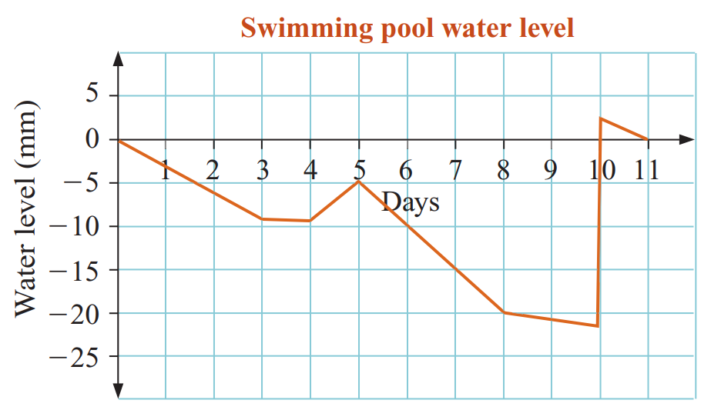
- Jade is investigating the rate at which water evaporates from her swimming pool.
One evening she fills the pool and marks a line at the recommended maximum level.
Each day at the same time she measures the distance from that mark to the current water level. Her results are shown in the graph.

  - What was the water level on day 3?
–9 mm
  - What was the rate of evaporation in mm per day for the first 3 days?
–3 mm/day
  - It rained a little on one day and then more on the next. Which days were these?
Day 3 and day 4.
  - Which 3 days were the hottest? (The evaporation is greatest when it’s hot)
Days 5, 6, 7
  - Jade filled the pool with the hose one evening but forgot to turn it off. When was this?
End of day 9

Combined Rates

Foundation
- Read the information on combined rates, then answer the questions.
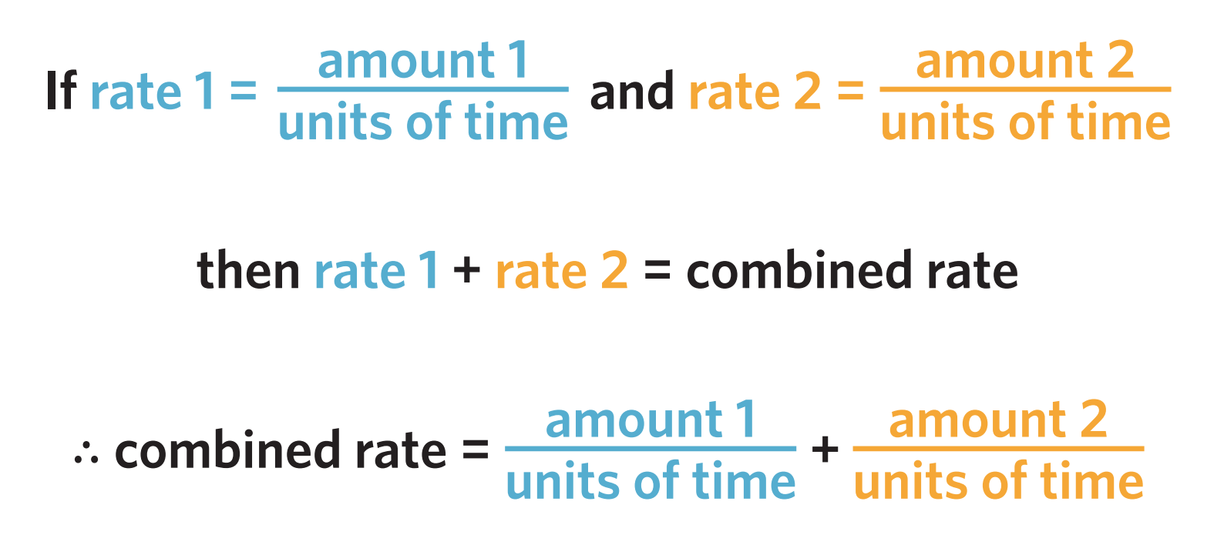

Worked Solution | Explanation
It takes Sean 20 hours to paint a house, while it would take Marty 25 hours to paint the same house. How many hours will it take Sean and Marty to paint the house together, to the nearest second?  $$Combined Rate=Sean+Marty \\ =\frac{1 house}{20 hours}+\frac{1 house}{25 hours} \\ =\frac{9 houses}{100 hours} \\ =\frac{1 house}{11.\dot{1} hours}$$  $∴11.\dot{1}$ hours, or 11 hours 6 minutes 40 sec | The fraction addition was performed using the calculator. Explain why it is important we show the units.  To interpret what the answer represents,  is it houses/hour or hours/house?  Explain why we changed the numerator to 1 instead of finding the unit rate.  The unit rate finds houses/hour, not hours/house  Explain how we can use the calculator to convert hours to minutes and seconds.  The $°^{ '} ''$ button converts between decimal and base 60.

- It takes two movers 6 and 5 hours respectively to move a one-bedroom apartment.
How long will it take both of them to move the apartment together, to the nearest minute?

2 hours 44 minutes

Development
- A cold-water tap can fill a bathtub in half an hour. A hot water tap can fill a bathtub in one hour.

Beatrix takes a guess:
Well, the average of 30 minutes and 60 minutes is 45. So, I reckon both taps would take 45 minutes.

Explain, without any calculations, why she must be incorrect.
She averaged the times instead of the rates. You add the rates of work, not average the times.
Intuitively, both taps must take less than 30 minutes.
Find how long it would take to fill the bathtub.

20 minutes
- Three water hoses are used to fill a large swimming pool.
The first hose alone would take 200 hours.
The second hose takes 120 hours and the third hose 50 hours.
How long would it take to fill the pool?

30 hours
- Michelle can complete a landscaping job in 6 days and Danielle can complete the job in 4 days. Working together, in how many days could they complete the job?

2 days 9 hours 36 minutes
- Mr Ding, Ms Fu and Mrs Falconer are organising the maths textbooks in the 8 bookshelves in the staffroom. Mr Ding by himself would take 25 hours to do all 8 bookshelves. Ms Fu can organise 2 bookshelves in 7 hours. Mrs Falconer can take 11 hours to organise 3 bookshelves. How long will it take if they work together? Answer to the nearest minute.

9 hours 6 minutes

Related Rates

- Related Rates Problems
Usually when working with rates, we only use two units.
Sometimes a question will give a third unit (or more).
To solve these problems:
- Identify the three quantities in the question.
- Set up a related rate equation.
$$\frac{Quantity 1}{Quantity 2}=\frac{Quantity 1}{Quantity 3}×\frac{Quantity 3}{Quantity 2}$$
- Substitute given information.
The scenario will always give two of the rates.
- Convert units to be the same, and to the unit wanted by the question.
- Simplify and solve the equation.

A common application is drip rates for medication, important for doctors and nurses.

- Example Solve problems involving related rates
Worked example | Your Turn
A patient must have 1.2 L of fluid over 4 hours through an intravenous drip.  There are 15 drops/mL.  How many drops per minute are required?  1. volume, time, drops.  2.  $$\frac{Drops}{Time}=\frac{Drops}{Volume}×\frac{Volume}{Time}$$  3.  $$\frac{Drops}{Time}=\frac{15 drops}{1 mL}×\frac{1.2 L}{4 hours}$$  4.  $$\frac{Drops}{Time}=\frac{15 drops}{1 mL}×\frac{1200 mL}{240 min}$$  5.  $$\frac{Drops}{Time}=\frac{75 drops}{1 min}$$  75 drops/min | What is the drop rate per minute if 1.3 L of fluid is to be delivered over 6 h with 12 drops/mL?  $43.3\dot{3}$ drops/min
- Example Solve problems involving related rates
Worked example | Your Turn
A drip is delivering 30 drops/min.  There are 20 drops/mL and 900 mL of liquid to be delivered.  How long will the drip take to deliver the required dose?  1. volume, time, drops.  2.  $$\frac{Time}{Volume}=\frac{Time}{Drops}×\frac{Drops}{Volume}$$  3.  $$\frac{x min}{900 mL}=\frac{1 min}{30 drops}×\frac{20 drops}{1 mL} \\ \frac{x min}{900 mL}=\frac{20 min}{30 mL}$$  5.  $x=$ 600 minutes | Calculate how long it will take to deliver  800 mL at 20 drops/min if there are  25 drops/mL.  1000 minutes
Worked example | Your Turn
A coffee shop buys coffee beans in 5 kg bags for $45 each.  Each cup of coffee uses 12 g of beans.  What is the cost of beans per cup of coffee?  1. cost, cup, beans.  2.  $$\frac{Cost}{Cup}=\frac{Cost}{Bean}×\frac{Bean}{Cup}$$  3.  $$\frac{Cost}{Cup}=\frac{\$45}{5000 g}×\frac{12 g}{1 cup}$$  5.  $$\frac{cost}{cup}=\$0.108/cup$$ | A car uses 8.2 L of fuel per 100 km.  Fuel costs $1.85 per litre.  What is the cost per kilometre?  $0.152/ km

Foundation
- Calculate the number of drops per minute required at a rate of 15 drops/mL in these situations.
- volume of 1.4 L over 7 h  50 drops/min | - volume of 1.5 L over 6 h  62.5 drops/min
- volume of 800 mL over 4 h  50 drops/min | - volume of 900 mL over 6 h  37.5 drops/min

- Calculate the time it will take to deliver intravenous liquid at these rates.
- 600 mL delivered at 15 drops/min and there are 10 drops/mL  6 h 40 min | - 500 mL delivered at 10 drops/min and there are 12 drops/mL  10 h
- 1.2 L delivered at 25 drops/min and there are 20 drops/mL  16 h | - 1.8 L delivered at 20 drops/min and there are 15 drops/mL  22 h 30 min

Development
- What is the drip rate per minute for 850 mL of fluid over 5 h with a drip size giving 8 drops/mL? Round to the nearest whole.

23 drops/min
- What is the drip rate per minute for 2.6 L of fluid over 6 h with a drip size giving 12 drops/mL?
Answer to the nearest whole number of drops.

87 drops/min
- A patient is to receive 800 mL of liquid through an intravenous drip delivering 25 drops/min.
If there are 16 drops/mL, how long will it take to deliver the required dose?

8 h 32 min
- A patient is to receive 1.5 L of fluid over 6 h through an intravenous drip.
If there are 12 drops/mL, how many drops per minute are required to deliver the dose?

50 drops/min

Mastery
- A patient is to receive 600 mL of saline solution.
An intravenous drip delivers 30 drops/min and there are 12 drops/mL.
How long will it take to deliver the required dose?

4 h
- What is the drip rate per minute for 1.25 L of fluid over 8 h, with a drip size giving 14 drops/mL? Round to the nearest whole.

36 drops/min
- A patient is to receive 1.1 L of fluid over 9 h.
Find the drip rate in drops/min if there are 18 drops/mL. Round to the nearest whole.

37 drops/min
- A patient needs 0.75 g of medicine per day. Pills contain 125 mg each and cost 75 c per pill.
What is the annual cost of medicine, in dollars?

$$\frac{Cost}{Time}=\frac{Medicine}{Time}×\frac{Pills}{Medicine} ×\frac{Cost}{Pills}$$
$$\frac{\$x}{1 year}=\frac{0.75 g}{1 day}×\frac{1 pill}{125 mg}×\frac{75 c}{1 pill}$$
$$\frac{\$x}{1 year}=\frac{0.75 g}{1÷365 years}×\frac{1 pill}{125÷1000 g}×\frac{\$0.75}{1 pill}$$
$$∴\$1642.50/yr$$
- A factory produces 25 widgets in 4 minutes. Each widget requires 15 g of plastic.
Plastic costs $3.20 per kg. What is the cost per hour, in dollars?

$$\frac{cost}{time}=\frac{widgets}{time}×\frac{plastic}{widget}×\frac{cost}{plastic}$$
$$\frac{\$x}{1 hour}=\frac{25 w}{4 min}×\frac{15 g}{1 w}×\frac{\$3.20}{1 kg}$$
$$\frac{\$x}{1 hour}=\frac{25 w}{4÷60 hr}×\frac{15÷1000 kg}{1 w}×\frac{\$3.20}{1 kg}$$
$$x=\$18/hr$$
- A large bag of flour weighs 24 kg and costs $21.50.
A sponge cake uses 150 g of flour per cake.
What questions do these calculations find out?
$$\frac{24000}{150}$$ | $$\frac{24}{21.50}$$ | $$\frac{2150}{24}$$ | $$\frac{21.50}{24000}×150$$
  - ………………………………………………………………………………………………………
Units are $\frac{g}{g/cake}$, so how many cakes can be made
  - ………………………………………………………………………………………………………
Units are $\frac{kg}{\$21.50}$, so kilograms of flour per dollar
  - ………………………………………………………………………………………………………
Units are $\frac{cents}{kg}$, so cents per kilogram
  - ………………………………………………………………………………………………………
Units are $\frac{\$}{g}×\frac{g}{cake}$ so dollars per cake

- Mr Ding makes maths booklets that are on average 25 sheets of paper.
Each ream of printing paper is 500 sheets.
A single sustainably farmed tree can produce approximately 10 000 sheets of paper.
Each ream of paper is $9.
He teaches 4 classes and prints a new booklet for each student once every two weeks.
Each class has on average 20 students.
How many trees does he use in a 38-week academic year, and how much do these booklets cost in paper?

First find how many sheets used per year:
$$\frac{20 students}{class} × 4 classes ×\frac{25 sheets}{book} ×\frac{0.5 books}{student⋅week} × 38 weeks = 38 000 sheets$$

Therefore, trees used per year:
$$38 000 sheets ÷\frac{10 000 sheets}{tree} = 3.8 trees$$

Cost per year:
$$38 000 sheets ÷ \frac{500 sheets}{ream}×\frac{\$9}{ream} = \$684$$

